MODELLING CONVOLUTIONAL NEURAL NETWORK FOR VEHICLE IDENTIFICATION PROBLEM

MUHAMMAD NIDZAM BIN MASO’OD

UNIVERSITI TEKNOLOGI MALAYSIA

PSZ 19:16 (Pind. 1/13)

UNIVERSITI TEKNOLOGI MALAYSIA

DECLARATION OF THESIS / POSTGRADUATE PROJECT REPORT AND COPYRIGHT

Author’s full name : MUHAMMAD NIDZAM BIN MASO’OD

Date of Birth : 13 JAN 1981

Title : MODELLING CONVOLUTIONAL NEURAL NETWORK FOR VEHICLE IDENTIFICATION PROBLEM

Academic Session :

I declare that this thesis is classified as:

|  |  |  |
| --- | --- | --- |
|  | CONFIDENTIAL | (Contains confidential information under the Official Secret Act 1972)* |
|  |  |  |
|  | RESTRICTED | (Contains restricted information as specified by the organization where research was done)* |
|  |  |  |
| ✓ | OPEN ACCESS | I agree that my thesis to be published as online open access (full text) |

1. I acknowledged that Universiti Teknologi Malaysia reserves the right as follows:
2. The thesis is the property of Universiti Teknologi Malaysia
3. The Library of Universiti Teknologi Malaysia has the right to make copies for the purpose of research only.
4. The Library has the right to make copies of the thesis for academic exchange.

|  |  |  |  |  |
| --- | --- | --- | --- | --- |
|  |  |  | Certified by: |  |
|  |  |  |  |  |
|  |  |  |  |  |
|  |  |  |  |  |
|  | SIGNATURE OF STUDENT |  | SIGNATURE OF SUPERVISOR |  |
|  |  |  | MOHD SYAHID BIN MOHD |  |
|  | MAN171043 |  | ANUAR |  |
|  | **MATRIX NUMBER** |  | **NAME OF SUPERVISOR** |  |
|  |  |  |  |  |
|  | Date: 14 JUNE 2019 |  | Date: 14 JUNE 2019 |  |

NOTES : If the thesis is CONFIDENTIAL or RESTRICTED, please attach with the letter from the organization with period and reasons for confidentiality or restriction

“I hereby declare that I have read this project report and in my

opinion this project report is sufficient in term of scope and quality for the

award of the degree of Master Of Science (Business Intelligence And Analytics)”

|  |  |  |
| --- | --- | --- |
| Signature | : | ________________________________ |
| Name of Supervisor I | : | MOHD SYAHID BIN MOHD ANUAR |
| Date | : | 14 June 2019 |
|  |  |  |
|  |  |  |
|  |  |  |
|  |  |  |
|  |  |  |
|  |  |  |
|  |  |  |
|  |  |  |
|  |  |  |
|  |  |  |

MODELLING DEEP LEARNING NETWORK FOR VEHICLE IDENTIFICATION PROBLEM

MUHAMMAD NIDZAM BIN MASO’OD

A project report submitted in fulfilment of the

requirements for the award of the degree of

Master of Science (Business Intelligence and Analytics)

Razak Faculty of Technology and Informatics

Universiti Teknologi Malaysia

JUNE 2019

DECLARATION

I declare that this project report entitled *“*MODELLING CONVOLUTIONAL NEURAL NETWORK FOR VEHICLE IDENTIFICATION PROBLEM *”* is the result of my own research except as cited in the references. The project report has not been accepted for any degree and is not concurrently submitted in candidature of any other degree.

|  |  |  |
| --- | --- | --- |
| Signature | : | .................................................... |
| Name | : | MUHAMMAD NIDZAM BIN MASO’OD |
| Date | : | 14 June 2019 |
|  |  |  |
|  |  |  |

DEDICATION

This project report is dedicated to my wife Tun Noor Adillah, who sacrificed a lot for me to finish my Master study and always being there to give me encouragement and motivation. It is also dedicated to my mother, Jumaah Bt. Yeop Tamin and my late father Masood bin Ali, who always taught me the value of knowledge and how it can improve the world. To my four children Muhammad Izz Khairy, Muhammad Rafie Azim, Nur Aina Sofia, and Muhammad Amin Naufal, I hope this will inspire you to chase your dreams in life.

ACKNOWLEDGEMENT

I would first like to thank my project report advisor Dr. Mohd Syahid bin Mohd Anuar of Razak Faculty of Technology and Informatics at UTM Kuala Lumpur. His door is always open for me whenever I encountered trouble and or had a question about my research or writing. He also consistently provided support and ideas for my Master project research and steering me in the right direction.

I would also like to thank my course coordinator Dr. Nurulhuda Firdaus Binti Mohd Azmi for all her support during the past 2 years and to all other lecturers who have taught me during this Master course studies. I’m very grateful for all the effort and time they have spent to educate me during this period.

My fellow master graduate students should also be recognized for their support. During the past 2 years, they have helped me a lot in my studies. They helped me to realize that we can achieve more by working in a team. My sincere appreciation also extends to all my work colleagues for all their supports and understandings.

Finally, I must express my very profound gratitude to my parents, my wife Tun Noor Adillah bt Mohammed Sohami and my four children Muhammad Izz Khairy , Muhammad Rafie Azim, Nur Aina Sofia, and Muhammad Amin Naufal for providing me with unfailing support and continuous encouragement throughout my years of study and through the process of researching and writing this project report. This accomplishment would not have been possible without them. Thank you.

ABSTRACT

From 2019, RFID electronic toll collection system (ETC) in Malaysia will slowly move from onboard unit (OBU) system to a low-cost sticker type RFID tag system in order to improve the acceptance of RFID. This will eventually paw the way for multiple-lane free flow system (MLFF) which eliminate tollgate islands and gate barriers and enables toll collection for vehicle traveling in any lane among multiple lanes. Implementation of RFID tag for the toll payment system in Malaysia came with the possibility of user fraud in which the RFID tag can be moved from one vehicle type to another vehicle type. To counter this, an application using Convolutional Neural Network (CNN) is proposed to detect and identify vehicle type and perform crosscheck with the RFID database. The proposed CNN algorithm needs to have high accuracy and fast inference time to be used in a live traffic monitoring system. Since currently available algorithms are not trained with Malaysia localized vehicle features, the proposed algorithm also needs to be trained using localized vehicle images sample. Based on above requirement, the purpose of this research is to study the enhancement of Convolutional Neural Network (CNN) by manipulating the number of filter layer and implementing on Graphical Processing Unit (GPU) to produce better accuracy and improve time. Two algorithms were selected and trained with localized image samples (Faster R-CNN-Inception v2 and SSD-Inception v2). From the research, it is found that the inference time for SSD-Inception v2 outperformed Faster R-CNN-Inception v2 by performing it 0.027 seconds faster. In terms of accuracy, mAP, the performance of the trained Faster R-CNN-Inception v2 and SSD-Inception v2 is statistically proven have no difference in performance.

ABSTRAK

Dari tahun 2019, sistem pengumpulan tol elektronik RFID (ETC) di Malaysia akan berubah dari sistem peranti di atas kenderaan (OBU) kepada sistem pelekat RFID jenis kos rendah untuk meningkatkan penerimaan RFID. Ini akhirnya akan membuka jalan untuk sistem aliran bebas berbilang lorong (MLFF) yang dapat menghapuskan plaza kutipan tol serta halangan pintu dan membolehkan kutipan tol dilakukan kepada kenderaan yang bergerak di mana-mana lorong. Pelaksanaan tag RFID untuk sistem pembayaran tol di Malaysia datang dengan kemungkinan penipuan pengguna di mana tag RFID boleh dipindahkan dari satu jenis kenderaan ke jenis kenderaan lain. Untuk mengatasi masalah ini, aplikasi menggunakan Rangkaian Neural Konvolusi(CNN) dicadangkan untuk mengesan dan mengenal pasti jenis kenderaan dan melakukan pemeriksaan dengan pangkalan data RFID. Algoritma CNN yang dicadangkan perlu mempunyai ketepatan yang tinggi dan masa inferensi yang cepat untuk digunakan dalam sistem pemantauan lalu lintas secara langsung. Disebabkan algoritma sedia ada tidak dilatih dengan ciri-ciri kenderaan setempat Malaysia, algoritma yang dicadangkan juga perlu dilatih menggunakan sampel imej kenderaan tempatan. Berdasarkan keperluan di atas, tujuan penyelidikan ini adalah untuk mengkaji peningkatan Rangkaian Neural Konvolusi (CNN) dengan memanipulasi jumlah lapisan penapis dan melaksanakan Unit Pemproses Grafik (GPU) untuk menghasilkan ketepatan yang lebih baik dan memperbaiki masa inferensi. Dua algoritma telah dipilih dan dilatih dengan sampel imej tempatan (Faster R-CNN-Inception v2 dan SSD-Inception v2). Dari penyelidikan yang dilakukan, didapati bahawa masa inferensi untuk SSD-Inception v2 mengatasi Faster R-CNN-Inception v2 dengan melaksanakannya 0.027 saat lebih cepat. Dari segi ketepatan, mAP, prestasi Faster R-CNN-Inception v2 dan SSD-Inception v2 yang telah dilatih sampel imej kenderaan tempatan, terbukti secara statistik tidak mempunyai perbezaan dalam prestasi.

TABLE OF CONTENTS

|  |  |  |
| --- | --- | --- |
|  | TITLE | PAGE |

DECLARATION iii

DEDICATION iv

ACKNOWLEDGEMENT v

ABSTRACT vi

ABSTRAK vii

TABLE OF CONTENTS viii

LIST OF TABLES xi

LIST OF FIGURES xii

LIST OF ABBREVIATIONS xiv

LIST OF SYMBOLS xv

CHAPTER 1 INTRODUCTION 1

1.1 Introduction 1

1.2 Problem Background 1

1.3 Problem Statement 6

1.4 Research Goal 7

1.5 Significant of the research 7

1.6 Research Objective 7

1.7 Research Questions 7

1.8 Scope 8

1.9 Outline 9

CHAPTER 2 LITERATURE REVIEW 11

2.1 Introduction 11

2.2 Convolutional Neural Network 11

2.3 CNN Architectures 12

2.3.1 Input 13

2.3.2 CONV layer 14

2.3.3 ReLU 18

2.3.4 POOL layer 19

2.3.5 Fully Connected (FC) layer 20

2.4 CNN common architectures 20

2.4.1 AlexNet 20

2.4.2 ZF Net 21

2.4.3 GooLeNeT 21

2.4.4 VGGNet 23

2.4.5 RESNET 23

2.5 Object Detection Framework 24

2.5.1 R-CNN 25

2.5.2 Fast R-CNN 27

2.5.3 Faster R-CNN 27

2.5.4 SSD 28

2.5.5 YOLO — You Only Look Once 30

2.6 Transfer Learning 31

2.7 GPU usage in Object Detection algorithm 32

2.8 Existing work 32

2.8.1 Image classification 33

2.8.2 Object detection 34

CHAPTER 3 RESEARCH METHODOLOGY 37

3.1 Introduction 37

3.2 Operation framework 37

3.2.1 Initiation stage 38

3.2.2 Data collection stage 39

3.2.2.1 Data sampling 39

3.2.2.2 Algorithm Selection 40

3.2.2.3 Images Selection 41

3.2.2.4 Metric selection 41

3.2.3 Reporting stage 42

3.3 Study phases 42

3.4 Tools and Platforms 43

3.5 Summary 43

CHAPTER 4 FINDING 45

4.1 Proposed system 45

4.2 Data pre-processing 46

4.3 Classification network 48

4.3.1 Faster R-CNN and SSD 48

4.3.2 YOLO 51

4.4 Training process evaluation 52

4.4.1 SSD-Inception v2 loss function 53

4.4.2 YOLOv3 loss function 55

4.4.3 Training process evaluation summary 57

4.5 Experiment design 58

4.6 Experiment results 60

4.6.1 Inference mAP 60

4.6.2 Inference time 63

4.6.3 Stability test 64

4.6.4 Paired sample t- test 66

4.7 Summary 68

CHAPTER 5 CONCLUSION 71

5.1 Research Outcomes 71

5.2 Contributions to Knowledge 72

5.3 Limitation 73

5.4 Future Works 73

REFERENCES 75

LIST OF TABLES

|  |  |  |
| --- | --- | --- |
| TABLE NO. | TITLE | PAGE |

Table 1.1 Classification of vehicles in Malaysia (Toll collection and toll rates, 2006) 4

Table 2.1 Existing work on image classification 33

Table 2.2 Existing work on object detection 35

Table 3.1 Summary of initiation stage 39

Table 4.1 Images split details 46

Table 4.2 Inception v2 architecture outline 50

Table 4.3 Algorithm loss summary 57

Table 4.4 Images used in experiments 58

Table 4.5 mAP results 60

Table 4.6 Object detection bounding box and mAP 61

Table 4.7 Inference time, t results 63

Table 4.8 mAP standard deviation and mean 64

Table 4.9 Inference time, t standard deviation and mean 65

Table 4.10 mAP Paired 2 sample t-test 67

Table 4.11 Inference time, t Paired 2 sample t-test 68

Table 4.12 Finding summary 68

LIST OF FIGURES

|  |  |  |
| --- | --- | --- |
| FIGURE NO. | TITLE | PAGE |

Figure 1.1 SmartTag system implementation in Malaysia 2

Figure 1.2 MLFF system 3

Figure 1.3 RFID tag attached to vehicle head lamp 3

Figure 1.4 Toll fare is different between vehicle class (Toll Fare, 2018) 5

Figure 1.5 Localized features of taxi in Malaysia 5

Figure 2.1 The LeNet architecture 12

Figure 2.2 CNN process 12

Figure 2.3 Array of RGB Matrix 13

Figure 2.4 Examples of RGB pixel value and it's colour name designation 14

Figure 2.5 Images matrix multiplies with filter(kernel) matrix 15

Figure 2.6 Sum of element-wise products 15

Figure 2.7 The convolutional process is repeated until all the pixel has been calculated. 16

Figure 2.8 Convolution example between a 5x5 image and 3x3 filter 16

Figure 2.9 Sample image 16

Figure 2.10 Operation and filter type 17

Figure 2.11 ReLU, when Input < 0 the output will 0 and when Input > 0 then linear with slope 1. 18

Figure 2.12 ReLU operation image example 19

Figure 2.13 Max Pooling 2x2 window and stride of 2 19

Figure 2.14 AlexNet structure 21

Figure 2.15 ZF Net structure 21

Figure 2.16 GoogLeNet structure 22

Figure 2.17 Inception module 22

Figure 2.18 VGGNet structure 23

Figure 2.19 ResNet architecture and it's residual block structure 24

Figure 2.20 General idea of object detection framework 25

Figure 2.21 R-CNN framework 26

Figure 2.22 R-CNN architecture 26

Figure 223 Fast R-CNN 27

Figure 2.24 Faster R-CNN 28

Figure 225 SSD architecture 29

Figure 2.26 4 prediction at each cell. 30

Figure 2.27 YOLO 31

Figure 3.1 Flowchart of Research Methodology 38

Figure 4.1 Proposed fraudulent cross-checking system 45

Figure 4.2 Image is annotate using labelImg 47

Figure 4.3 Example of the XML file structure 47

Figure 4.4 images folder structure 48

Figure 4.5 Inception modules where each 5×5 convolution is re-placed by two 3×3 convolution 49

Figure 4.6 Inception modules after the factorization of the n×n convolutions. In this architecture n=7 for 17x17 was selected. 49

Figure 4.7 Inception modules with expanded the filter bank outputs. This architecture is used on the coarsest (8×8) grids to promote high dimensional representations. 50

Figure 4.8 YOLOv3 architecture 51

Figure 4.9 Faster R-CNN-Inception v2 loss for experiment training dataset 53

Figure 4.10 SSD-Inception v2 loss for experiment training dataset 55

Figure 4.11 YOLOv3 loss for experiment training dataset 57

LIST OF ABBREVIATIONS

|  |  |  |
| --- | --- | --- |
| CNN | - | Convolutional Neural Network |
| RFID | - | Radio Frequency Identification |
| ETC | - | Electronic Toll Collection |
| OBU | - | On Board Unit |
| MLFF | - | Multiple-lane Free Flow System |
| FC | - | fully connected |
| R-CNN | - | Region Convolutional Neural Network |
| YOLO | - | You Only Look once |
| SVM | - | Support Vector Machine |
| RoI | - | Region of Interest |
| mAP | - | mean Average Precision |
|  |  |  |
|  |  |  |
|  |  |  |
|  |  |  |
|  |  |  |
|  |  |  |
|  |  |  |
|  |  |  |
|  |  |  |
|  |  |  |
|  |  |  |
|  |  |  |
|  |  |  |
|  |  |  |

LIST OF SYMBOLS

|  |  |  |
| --- | --- | --- |
| h | - | Height |
| w | - | Weight |
| d | - | Depth |
| $$f_{h}$$ | - | Filter Height |
| $$f_{w}$$ | - | Filter Weight |
|  |  |  |
|  |  |  |
|  |  |  |
|  |  |  |
|  |  |  |
|  |  |  |
|  |  |  |
|  |  |  |
|  |  |  |
|  |  |  |
|  |  |  |
|  |  |  |
|  |  |  |
|  |  |  |
|  |  |  |
|  |  |  |
|  |  |  |

# 

# INTRODUCTION

## Introduction

Deep Learning application in image recognition has been popular for the past few years since the breakthrough of Convolutional Neural Network (CNN) by Yann LeCun with the introduction of LeNet (Y. LeCun, 1998). Advances in computing power enable data to be processed faster. As an example, the recent advancement of GPU (Graphical Processing Unit) with highly threaded parallel computing processors manage to achieve higher processing speed compared with CPU (Boyer & Baz, 2013). Machine learning framework such as TensorFlow (Abadi, et al., 2016), PyTorch (Ketkar, 2017), Keras (Moolayil, 2018), and MXNet (Chen, et al., 2015) helped to speed up machine learning development and also can help to scale the machine learning to production with ease. New concept in CNN such as transfer learning (Hussain M. a., 2018) and pre-trained model helped to reduce the amount of data and shorten the time needed for CNN model training

Some of the application of CNN is plate number detection (Mondal, Mondal, Saha, & Chattopadhyay, 2017), health image classification (Sujit, et al., 2018), product defect detection in factories (Ooi, Tay, & Lai, 2019) and a lot more. In this project, we will explore the application of CNN in solving some of the issues arising from RFID (Radio Frequency Identification) electronic toll collection system (ETC) implementation in Malaysia

## Problem Background

Malaysia highway toll operators have been using RFID electronic toll collection system (ETC) for quite some time since the introduction of SmartTag in the year 2004. This system has been introduced to alleviate the traffic congestion that occurs at toll gates on expressways. However, the SmartTag system uses onboard unit (OBU) which is expensive causing the penetration rate of the RFID ETC system to be sluggish. As shown in figure 1.1, the current example of SmartTag system implementation in Malaysia.

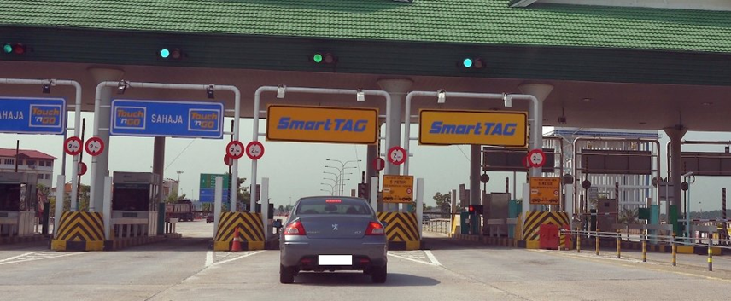

Figure 1.1 SmartTag system implementation in Malaysia

To improve acceptance of RFID, the practical application of a toll system using a low-cost sticker type RFID tag as an OBU which can benefit both users and expressway operators has been proposed (Tatsuya, et al., 2016). The field test of low-cost sticker type RFID tag in Malaysia has been conducted since 2015 with the collaboration between Mitsubishi Heavy Industries, Touch'n Go and Quatriz. The implementation low-cost sticker type RFID will eventually make the way for multiple-lane free flow system (MLFF) (Noriani, Suriani, Nurulhuda, Rasimah, & Norziha, 2016) which will eliminate tollgate islands and gate barriers and enables toll collection for vehicle traveling in any lane among multiple lanes as shown in figure 1.2.

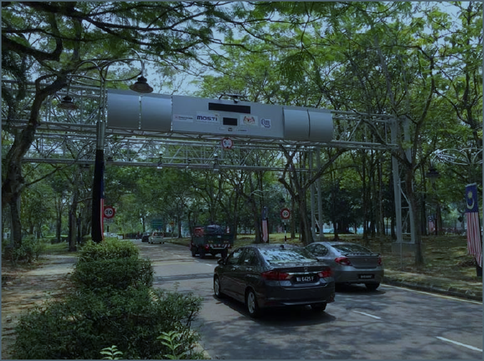

Figure 1.2 MLFF system

The implementation of low-cost sticker type RFID in Malaysia will come in the form of a sticker with tiny grain-like chip and an antenna as shown in figure 1.3. Since it is “follow the car” system, it needs to be installed and registered on one vehicle. If you have two vehicles, you need to register both and have 2 different RFID tags attached. This RFID tag will be linked to the owner’s Touch n Go (payment provider) eWallet app. Toll fare will be deducted from the user account when the RFID is scan by an overhead scanner when the vehicle passes through the toll.

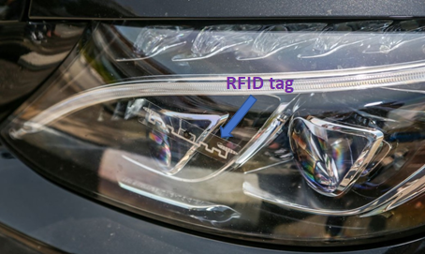

Figure 1.3 RFID tag attached to vehicle head lamp

However, by implementing low-cost sticker type RFID, it can expose the toll operator to the fraudulent act by expressway users. In general, vehicles in Malaysia are being classified into 6 classes. The classes categorization can be explained as in below table 1.1.

Table 1.1 Classification of vehicles in Malaysia (Toll collection and toll rates, 2006)

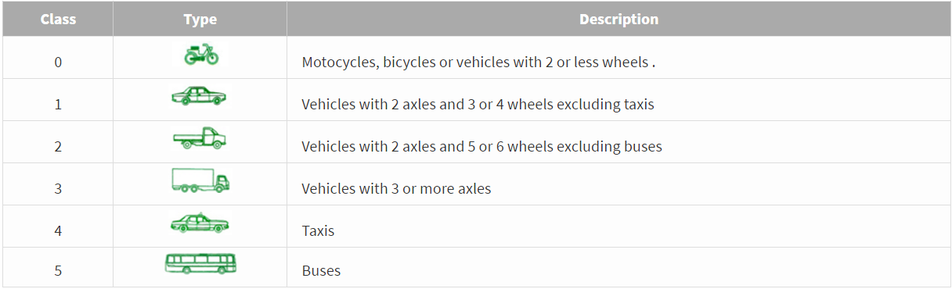

Toll payment for an expressway in Malaysia is based on the class of the vehicles. Fare for public transport will usually be lower than another type of vehicles. Figure 1.4 below shows the example of how fare is different according to the vehicle class.

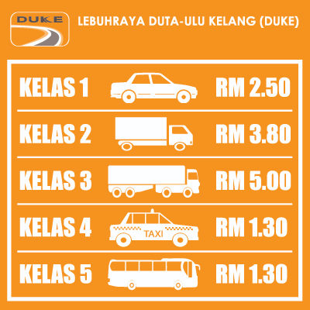

Figure 1.4 Toll fare is different between vehicle class (Toll Fare, 2018)

Sticker type RFID can be easily transferred from one vehicle to another one. If a lower fare class sticker ID is transferred to a higher-class vehicle for example from a taxi to a small truck that has a double fare amount compared to the taxi, this will cause expressway operators to lose money. To reduce the risk, A fraud cross-checking system using visual recognition is being proposed in this project. This system should be able to recognize and classify the vehicles including the localized feature of vehicles in Malaysia as shown in figure 1.5.

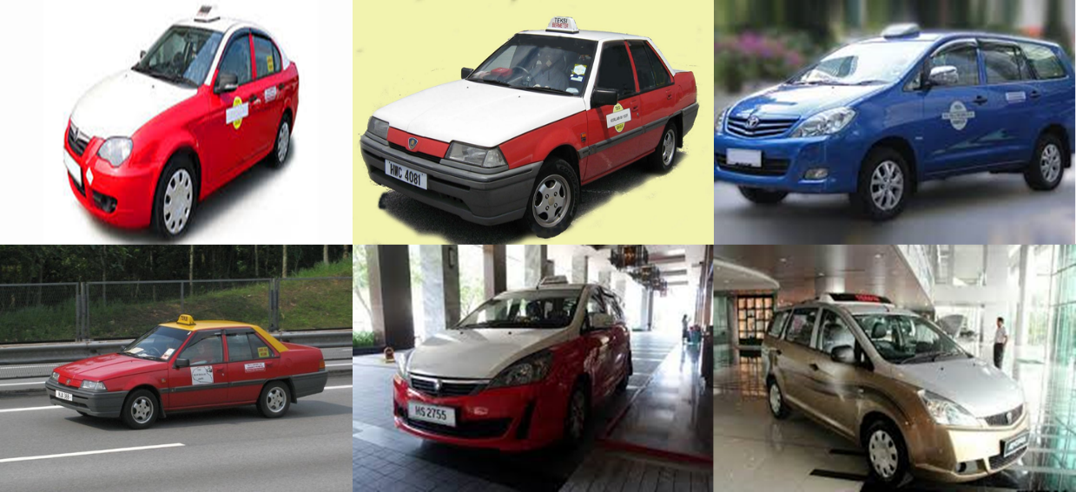

Figure 1.5 Localized features of taxi in Malaysia

There are several works where CNN application in vehicle classification have been studied such as in (Wang, Li, Zhang, & Ji, 2017) and (Mayank Singh Chauhan, Arshdeep Singh, Khemka, Prateek, & Sen, 2019). Wang (2017) uses a public dataset published in (Jonathan Krause, 2013) to train their CNN model. This dataset, however, contains only images for car only. Mayank Singh Chauhan (2019) uses dataset consist of images collected from Delhi and the National Capital Region (NCR) in India to train their CNN model. This research pointed out the low accuracy result when inferring images taken from Delhi and the National Capital Region (NCR) using CNN model trained using public dataset such as Cityscapes Dataset (M. Cordts, et al., 2016), KITTI dataset (Geiger, Lenz, & Urtasun, 2012) and TRANCOS Dataset (Guerrero-Gómez-Olmedo, Torre-Jiménez, López-Sastre, Bascón, & Oñoro-Rubio, 2015) compared to CNN model trained using Delhi and the National Capital Region (NCR) images dataset. This show the importance of using localized images dataset when training a CNN model to be used in local application.

Training a whole new dataset on CNN from scratch, however, would require extensive computational resources. It can take a long time to complete the training and sometimes it may take days or even weeks. This was highlighted by the author (Hussain, Bird, & Faria, 2018). The proposed system also needs to be able to incept the image fast. As mentioned in (Nakagawa, 2018), excessive processing time would not only occur at convolution and full connection layers but other modules such as data pre-processing also need a fair amount of time to process.

## Problem Statement

To minimize the risk of RFID fraud, a fraudulent cross-checking system using visual recognition needs to be developed. The system needs to consider the various localized features of vehicles in Malaysia, the accuracy of the detection and speed of the inference time to cater for high-speed movement of the vehicles on expressway. Therefore, the purpose of this research is to have “An enhancement of CNN by manipulating the number of filter and layer and implementing on GPU to produce better accuracy and improve processing time.”

## Research Goal

This research attempts to identify the best CNN architecture for the proposed vehicle visual recognition system that enables it to identify the vehicle by its classes accurately and fast.

## Significant of the research

The significance of the research is to implement deep learning algorithm using CNN in a real-life situation that can bring impact to the business. Another significant impact of this research is, to identify which CNN algorithm that is suited for actual business use case as stated in our problem background

## Research Objective

The research objectives (RO) can be further detailed as follows:

1. To identify the CNN architecture and technique.
2. To develop CNN model on GPU for vehicle recognition.
3. To evaluate the proposed model performance by comparing it with other selected CNN architecture.

## Research Questions

The following research questions (RQ) are used, to achieve the research objectives.

RQ1: What is the CNN architecture that give better accuracy?

RQ2: How to run CNN model on GPU?

RQ3: How to evaluate the proposed model performance?

## Scope

The scopes of this research are as below,

1. This research will only focus on the CNN architecture and technique used to speed up training and that can reduce the training sample required for CNN training.
2. The samples used for this training are images of class 1,2,3,4,5 types of vehicles collected from the internet with the total sample size of 448 images. The images are split into two folders. 90 images in the test folder and 358 images in the training folder.
3. For object classification, the research will classify image of vehicle consists of cars (class 1), lorries (class 2 and class3), taxis (class 4) and busses (class 5).
4. The performance measurement of the CCN will be using below two metrics.
5. mean Average Precision (mAP)
6. Inference time t, in second
7. This project will only focus on Malaysia transportation vehicles.

## Outline

This research consists of five chapters. Each chapter is written to be self-explanatory and complete.

Chapter 1 will describe the introduction of the research by going into details on the problem background, problem statement, research goal, significant of the research, research objective and research questions. In this chapter, the problem of potential FRID fraud which requires a fraudulent cross-checking system using visual recognition that needed to be accurate, fast and can also detect local vehicle features is described. To alleviate this, CNN model which is enhanced by manipulating the number of filter and layer that run on GPU is proposed.

Chapter 2 will brief on the literature review that has been conducted for this research. The focus of the literature is CNN, CNN architecture, CNN common algorithms, object detection framework, and transfer learning. As this research is aiming at the accuracy and the inference performance of CNN model, a details study has been conducted on the evolution of CNN and object detection algorithm. The weakness, strength, and performance of these algorithms are then summarized.

Chapter 3 will describe the research methodology by outlining the steps taken to complete the research. It will explain on data collection methods, experiment environment setup, performance measurement metrics of the trained model, software and hardware requirement that is required to finish the research.

Chapter 4 will brief on the finding from the research experiments which consists of data pre-processing, loss function of CNN model, training process evaluation finding from research experiment, experiment design and experiment result. The result from research experiment such as inference mAP, inference test, stability test, and paired sample t-test is also explained and summarized in this chapter

Chapter 5 will describe the research conclusions. The best model for the research problem statement is proposed. This chapter will also brief on the limitation and future work for the research.

# LITERATURE REVIEW

## Introduction

The development in computing processing power has propelled the usage of deep learning for object recognition or image classification purposes. Convolutional Neural Network (CNN) has become more popular with researcher as various new algorithm are being developed each year. This is also being helped with the advancement in the field of big data which enable a large scales online image database such as ImageNet (Deng, et al., 2009) ,MNIST (LeCun, Cortes, & J.C. Burges, 2010) and Microsoft COCO (Lin, et al., 2014) providing the datasets needed for deep learning. This chapter will go through on the basics of CNN, CNN Architecture, CNN common architecture, object detection framework, and transfer learning.

## Convolutional Neural Network

Convolutional Neural Network (CNN) is a deep learning technique that uses feed-forward neural networks (the connection between the nodes of an artificial neural network that does not form a loop or circle) and it mostly used for analysing images by recognizing the visual pattern from pixel and require minimal data pre-processing. The human brain biological structure with networks of interconnected neurons inspired the development of deep learning. In order to teach deep learning to recognize pattern from input, millions of data instances are feed into neuron networks which replicates the human brain function. According to Tom Hope (2017), deep learning is a process in which raw inputs such as values in an image pixel, are feed into deep neural network and transform the data into useful information by extracting higher-level features (for example shapes and edges in images). The combination of this information then captured as a complex concept and used to solve tasks such as image classification. Yann LeCun (1998) in his work, proposed one of the earliest CNN architecture, LeNet-5 that is designed for character recognition (handwritten and machine-printed character) in digitized 32x32 pixel images format. The framework of LeNet-5 which comprises of 7 layers of CNN is shown in figure 2.1.

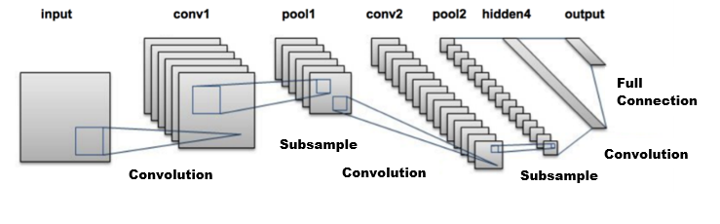

Figure 2.1 The LeNet architecture

CNN can be summarized as below figure 2.2, which is the combination of Input, input data features learning process and classification process.

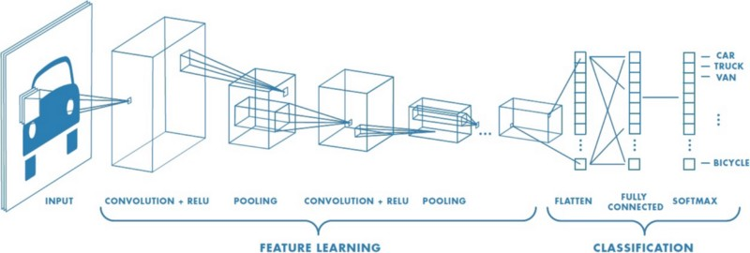

Figure 2.2 CNN process

## CNN Architectures

In this topic, details on CNN architecture (Albawi, Mohammed, & Al-Zawi, 2017) is explained. CNN basic architecture is as below:

1. INPUT
2. CONV layer
3. ReLU
4. POOL layer
5. FC (Fully connected Dense) layer

### Input

An image may be illustrated in the manner of 3D matrix of pixel values with the dimension representing the location of the pixel (height and width) and depth (dimension representing the colour channel in an image (RGB)). This value is used as input for CNN. An image of 6X6X3 is illustrated in figure 2.3.

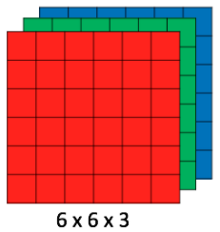

Figure 2.3 Array of RGB Matrix

The brightness of the pixel represented by a single number will determine the pixel value of a grayscale image. Byte is typically used as the image pixel format. The number is then cached as an 8-bit integer with the possible values varying from 0 to 255. In this format, 0 is defined as black, and 255 is defined as white shown in figure 2.4.

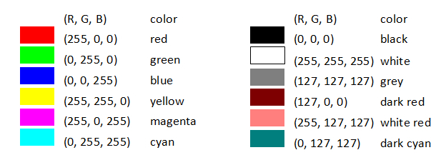

Figure 2.4 Examples of RGB pixel value and it's colour name designation

### CONV layer

The principal block for CNN is the CONV layer. It is the initial layer that will extract features out of an input image. Convolutional can be defined as a mathematical process that takes two inputs which comprise an image matrix and a filter (kernel) as shown in figure 2.5.

The mathematical relationship of CONV layer can be further illustrated as below

Image matrix of an image can be represented as $\left(h×w×d\right)$

Filter (kernel) can be represented as $\left(f_{h}×f_{w}×d\right)$

Output of convolutional of can be calculated as below

|  |  |
| --- | --- |
| $$Output=\left(h-f_{h}+1\right)×\left(w-f_{w}+1\right)×1$$ | (2.1) |

Where;



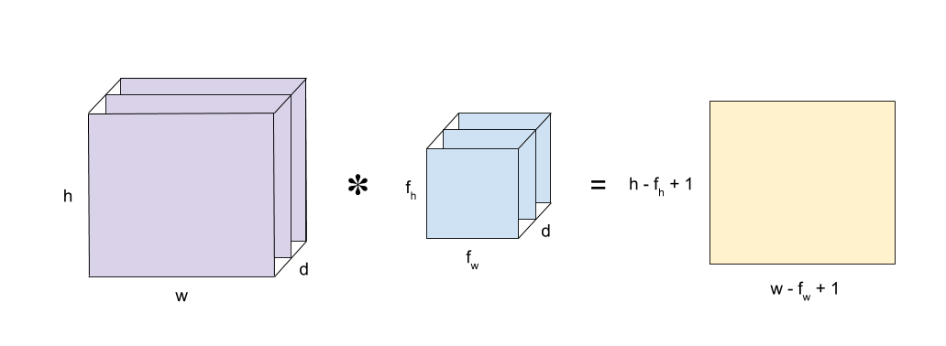

Figure 2.5 Images matrix multiplies with filter(kernel) matrix

To calculate the output of convolutions, the filter is being placed at the top-left corner of the input image. The convolution output will be the sum of element-wise product between the top pixel and the filter as shown in figure 2.6.

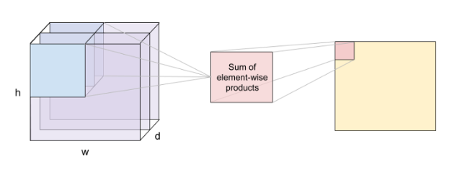

Figure 2.6 Sum of element-wise products

This process is then repeated by moving the filter to the right and repeating the convolution process to the next pixel value until all the image pixels have been covered. The movement of the filter from left to right is called a ‘stride’. (Refer to figure 2.7)

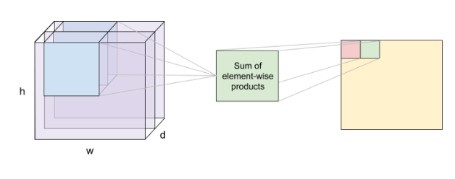

Figure 2.7 The convolutional process is repeated until all the pixel has been calculated.

The next figure 2.8 shows an example of convolution between a 5x5 image with a 3x3 filter with a stride of 1.



Figure 2.8 Convolution example between a 5x5 image and 3x3 filter

The filter is actually feature detector from the original picture. As an example, for the following images in figure 2.9:



Figure 2.9 Sample image

When the numeric value of the filter is changed, it can carry out processes such as edge detection, curve detection, image sharpening or blurring as shown in figure 2.10.

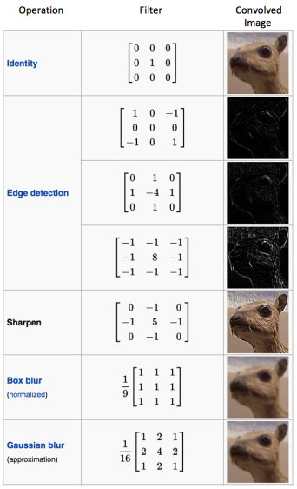

Figure 2.10 Operation and filter type

The size of the feature after image convolution operation is calculated using three parameters as mentioned below.

|  |  |
| --- | --- |
| Depth: | The number of filters utilized in the network |
| Stride: | The number of pixels which specific filter is slid across the input matrix |
| Zero-padding: | To ensure that filter can be applied to the pixel elements around the edge of an image, zero value is padded to the border of the image |

### ReLU

The convolution layer output is passed to the activation function ReLU (Rectifier Linear Unit) which is a non-linear operation. The outcome of this process is given by:

|  |  |
| --- | --- |
| $$Output=Max\left(zero,Input\right)$$ | (2.2) |

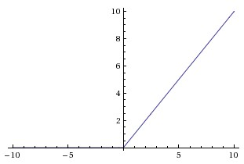

Figure 2.11 ReLU, when Input < 0 the output will 0 and when Input > 0 then linear with slope 1.

ReLU is an element-wise operation where the calculation is done pixel by pixel. It then converts negative pixels in the Feature Map to 0. ReLU is introduced because real-world data for CNN are mostly non-linear Because convolution is a linear operation (element-wise multiplication and addition), non-linearity in data is resolved by using a non-linear function such as ReLU. ReLU function is also shown to speed up the training several times faster compared using tanh activation function (Krizhevsky, 2012). The image after ReLU operation has been applied onto it is called a Rectified Feature Map.

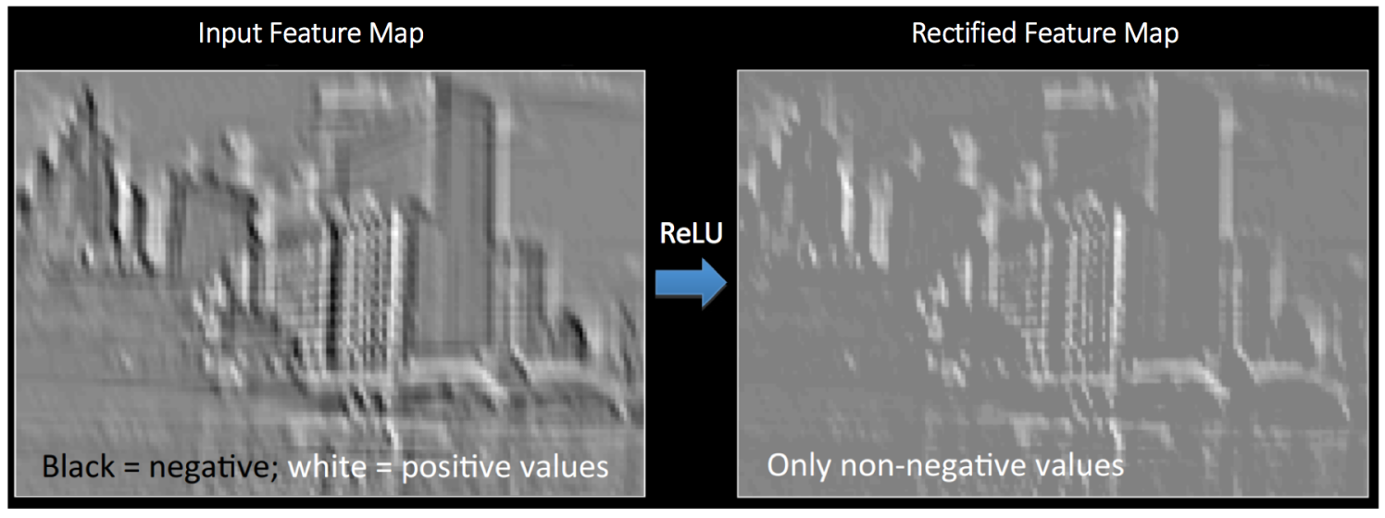

Figure 2.12 ReLU operation image example

### POOL layer

Convolutional layer output (extracted feature from the input) is then transferred to the pooling layer. The pooling layer functioned via reducing the size of the data by down sampling the input dimension but preserving the most relevant details. While various pooling types are available such as Max, Average, and Sum, the most commonly used pooling type is Max Pooling.

In Max Pooling, a 2x2 window is specified and from the Rectified Feature Map, the largest element value is taken. The window then slides two cells (stride value is 2) and the maximum value from every region is captured. In this way, the Feature Map dimension is reduced as shown in figure 2.12.

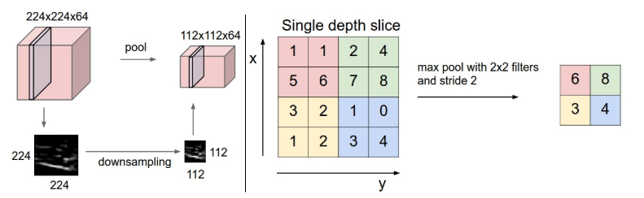

Figure 2.13 Max Pooling 2x2 window and stride of 2

### Fully Connected (FC) layer

After the pooling layer, data is flattened and then feed into an FC layer. FC layer purpose is to add non-linearity to the data. With FC layer, all the image feature is combined to create a complex model that could give the network prediction of the features as for the location of the features should be located. Activation function such as softmax or sigmoid is used to output the result.

## CNN common architectures

CNN common architectures refer to different designs of CNN networks that have been developed for the past years. This section will review some of the CNN architecture which are AlexNet, ZF Net, GooLeNet, VGGNet, and RESNET. This section will also briefly be discussing on object detection frameworks such as R-CNN, Fast R-CNN, Faster R-CNN, SSD, and YOLO.

### AlexNet

AlexNet (Krizhevsky, 2012) was released in the year 2012. This architecture obtained the 1st place for ImageNet Large Scale Visual Recognition Challenge (ILSVRC) in 2012. AlexNet has a deeper and larger CNN compared to LeNet. AlexNet comprised of eight layers. These layers are made of five convolutional layers and three dense layers. The first five layers are the combination of convolutional and max-pooling layers while the final three layers are constructed using dense layer (FC layers). AlexNet uses ReLU as the activation function since it produces a better result than using tanh and sigmoid function. AlexNet structure is shown in figure 2.14.

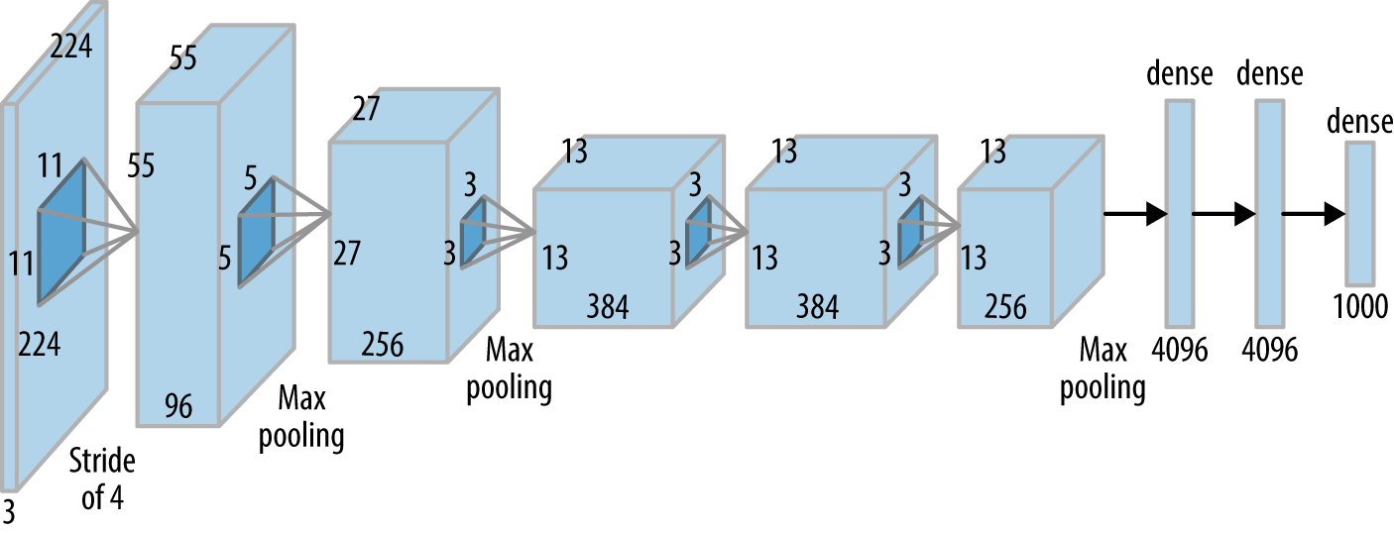

Figure 2.14 AlexNet structure

### ZF Net

ZF Net (Zeiler & Fergus, 2014) was published in the year 2013 and it was the winner for ILSVRC 2013. This architecture is an enhancement to AlexNet architecture by fine-tuning the hyperparameters. Some of the fine-tuning done were to expand the middle convolutional layers and having the stride and filter size smaller on the initial layer. ZF Net structure is illustrated in figure 2.15.

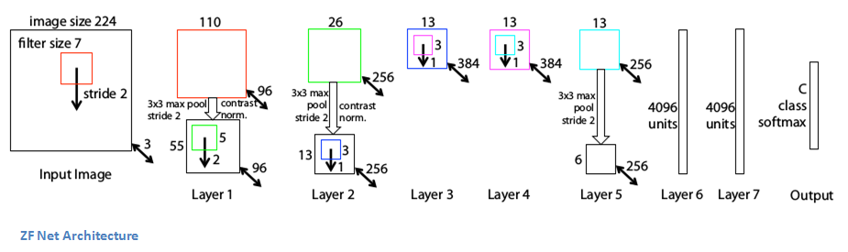

Figure 2.15 ZF Net structure

### GooLeNeT

GoogLeNet (Szegedy, et al., 2015) is the winner of ILSVRC 2014. This architecture introduces the Inception Module that effectively reduces the number of parameters in CNN network. Rather than using FC layers at the end of CNN, GoogLeNet uses Average Pooling thus reducing a large number of parameters. The structure of GoogLeNet is shown in figure 2.16. Figure 2.17 shows the structure of the inception module.

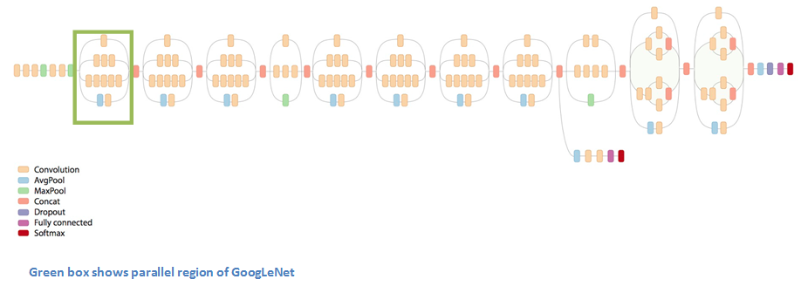

Figure 2.16 GoogLeNet structure

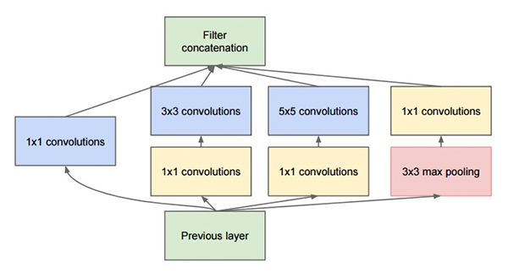

Figure 2.17 Inception module

### VGGNet

VGGNet (Simonyan & Zisserman, 2015)was the runner-up in ILSVRC 2014. VGG (Visual Geometry Group) is a research group from the University of Oxford. Only two types of convolutional layers are being used in VGGNet architecture which is 3x3 convolution layer and 2x2 pooling layer and this gives more depth to the network. By giving depth to the network, VGGNet shows the importance of depth as a deeper network yield better outcome. However, due to its depth, this architecture will contain a big parameter, especially in the FC layers. The training of the dataset will also take a longer time. The structure of VGGNet can be illustrated in figure 2.18.

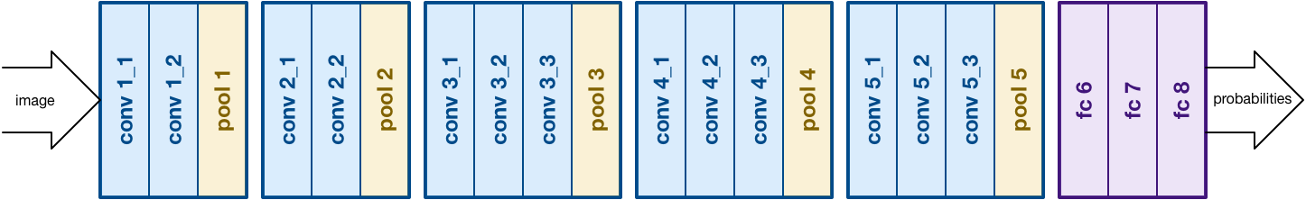

Figure 2.18 VGGNet structure

### RESNET

ReSNet (He, Zhang, Ren, & Sun, 2016) stands for residual neural networks. It is the winner in ILSVRC 2015 classification and in LSVRC and COCO 2015 competition. This architecture solved the degradation problems (accuracy get saturate and degrades rapidly) which occur as the network number of layers (depth) became larger with the introduction of Residual block. The ReSNet structure is displayed in figure 2.19.

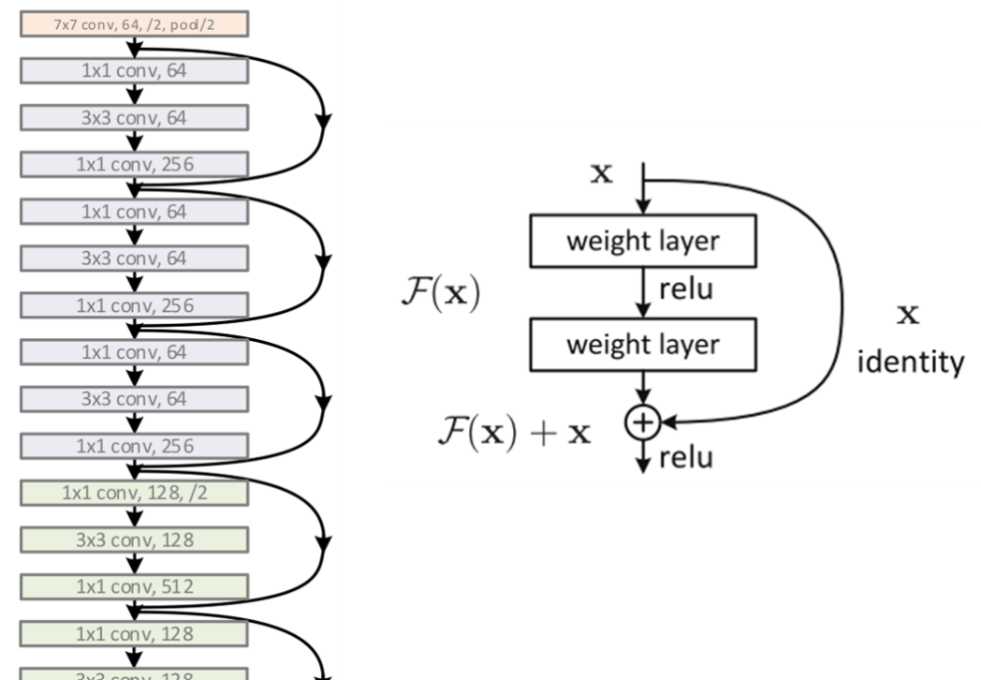

Figure 2.19 ResNet architecture and it's residual block structure

## Object Detection Framework

While CNN can be used to classify an image, some method to locate and detect the object of interest inside an image is needed. The method also should able to know where exactly the location object of interest inside the image is. Object detection purpose is to locate and classify objects existence in any one image and creating a rectangular bounding box drawing surrounding the position of an object and labelling them to show the confidence of existence (Zhao, Zheng, Xu, & Wu, 2019). For object detection, there could be many objects of interest within an image, so it does not necessarily draw just one bounding box as many bounding boxes may be needed. A simple approach to solve this is by extracting from the image different regions of interest. CNN is then used to classify if the object is presence within the extracted region. However, this approach will cause some problems since the objects of interest might have various aspect ratio and spatial locations within the image. Sizable regions number needed to be selected and would require an absurd amount of computation. Development of object detection algorithms such as R-CNN, Fast R-CNN, Faster R-CNN, SSD, and YOLO help to improved object detection speed and accuracy of detection.

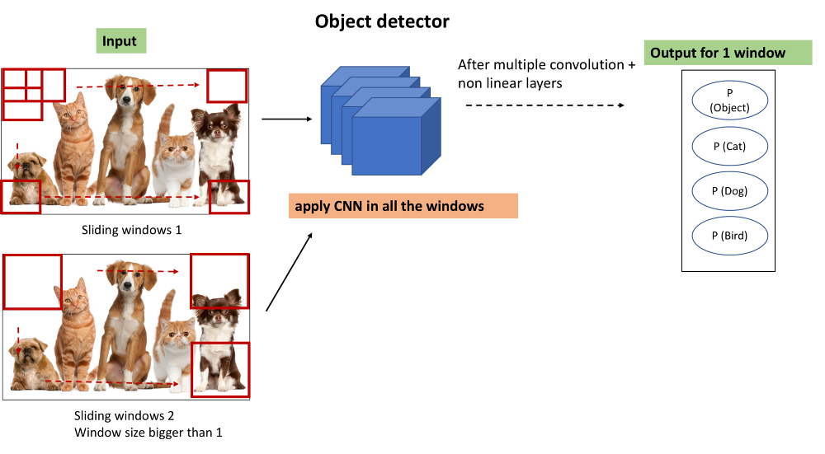

Figure 2.20 General idea of object detection framework

### R-CNN

R-CNN (Girshick, Donahue, Darrell, & Malik, 2014) which stands for Region in CNN was proposed in 2014. This method proposed the usage of selective search to derived just 2000 regions from the image (region proposal). Thus, the algorithm can just work with 2000 regions instead of huge number of regions. The 2000 regions proposal is generated using selective search algorithm.

Selective Search:

1. Generate initial sub-segmentation and then multiple candidate regions.
2. Similar regions are merged into larger ones recursively by using Greedy algorithm.
3. Generated regions are applied to attain the final candidate region proposal.

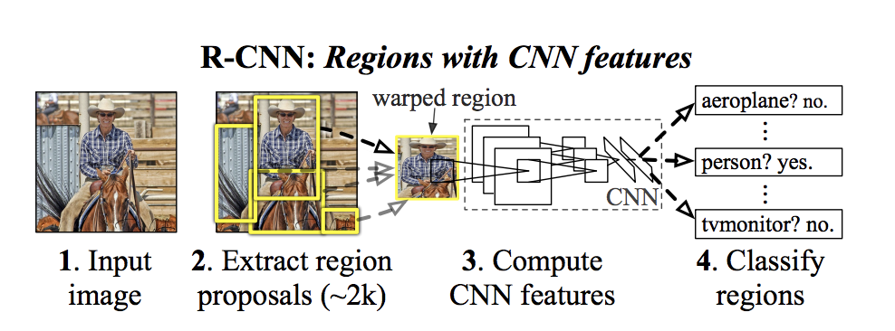

Figure 2.21 R-CNN framework

These generated region proposals (2000 candidates) are then warped into a square. It is then fed into a CNN in which 4096-dimension feature vector is produced as output. CNN will extract features from the image. The output from dense layer comprises of features obtained from the input is then fed to SVM to classify whether the object exists in that candidate region proposal. Furthermore, to predict if an object exists within the region proposals, four values are predicted by the algorithm as the offset value to improve the bounding box precision. For instance, in an input image with the presence of a human, given a region proposal, the presence of the human would have been predicted by the algorithm. However, the body of the human inside of that region proposal could possibly be split into two. The offset in the value will have to adjust the region proposal bounding box.

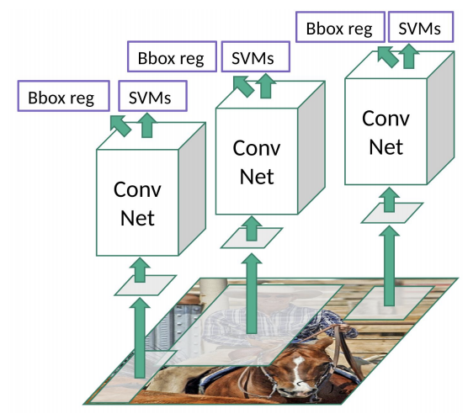

Figure 2.22 R-CNN architecture

R-CNN, however, requires a considerable amount of time for the network to be trained and real-time detection is not feasible. The selective search algorithm (a fixed algorithm) usage, prevents the learning process to happen at this step and could possibly lead to bad candidate region proposals to be generated.

### Fast R-CNN

To work out some of the disadvantages from R-CNN, Fast R-CNN (Girshick, 2015) an improved in speed for object detection algorithm was suggested. The method used is identical to R-CNN but in place of region proposals, the input image is fed into the CNN to generate a convolutional feature map. Region proposals then are identified from the convolutional feature map and warp into squares. Using Region of Interest (RoI) pooling layer, region proposals are reshaped into a fixed size, so it can be feed into FC layer. From the RoI feature vector, class prediction of the proposed region and offset values for the bounding box is done using a softmax layer. Since it does not need to feed 2000 region proposal as in R-CNN to the network and the convolutional operation and feature map generation is done only once per image, making this architecture faster than R-CNN.

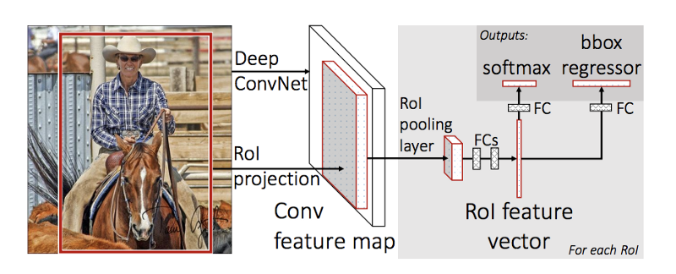

Figure 223 Fast R-CNN

### Faster R-CNN

The usage of selective search in R-CNN and Fast R-CNN is both time-consuming and slow thus affecting the network performance. A new algorithm has been proposed which eliminates the selective search algorithm and enables the network learning process to happen in the region proposal. This algorithm, Faster R-CNN (Ren, 2015) introduces a separate network to predict the region proposals. An RoI pooling layer is used to reshape the predicted region proposals. This layer, therefore, is utilized to classify image in the proposed region. The offset value for the bounding box is then predicted from this pooling layer.

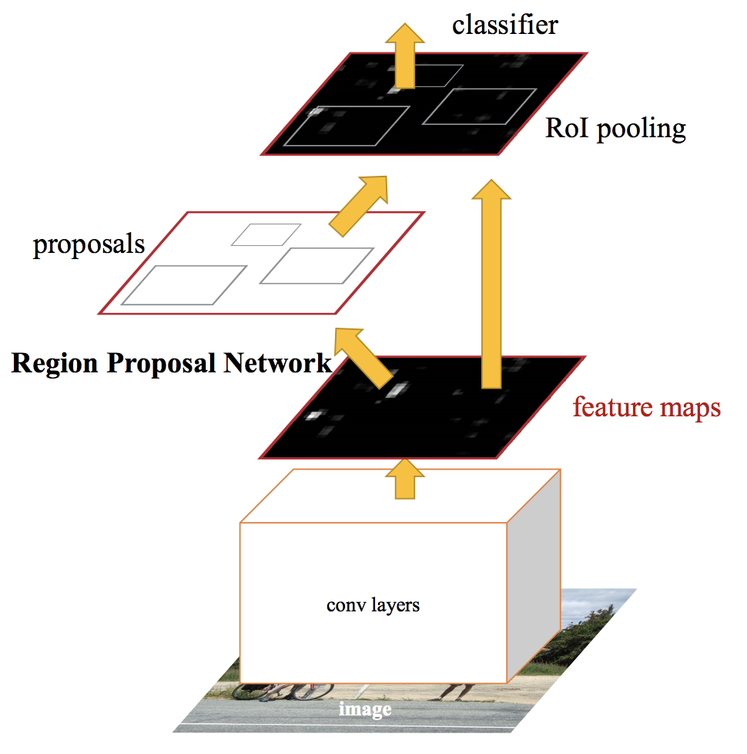

Figure 2.24 Faster R-CNN

### SSD

SSD stands for Single Shot Multibox Detector (Liu, et al., 2016) was proposed in 2016 to address the bottleneck issues of R-CNN and its successor. The algorithm can achieve a score of 74% mAP (mean Average Precision) on standard datasets such as PascalVOC and COCO and can infer images at 59 fps (frames per second) on these datasets. SSD structure can be briefly explained as below:

|  |  |
| --- | --- |
| Single Shot: | Object localization and classification task are done in a single forward pass of the network |
| MultiBox: | Bounding box regression technique refined for SSD architecture. |
| Detector: | The network function as an objects detector and can classifies the detected objects |

SSD eliminates the usage of region proposal thus speeding up the process. However, to prevent drop-in accuracy, SSD applies multi-scale features and default boxes. These enable SSD’s accuracy to be on par with Faster R-CNN’s accuracy by using lower resolution images that allow higher processing speed.

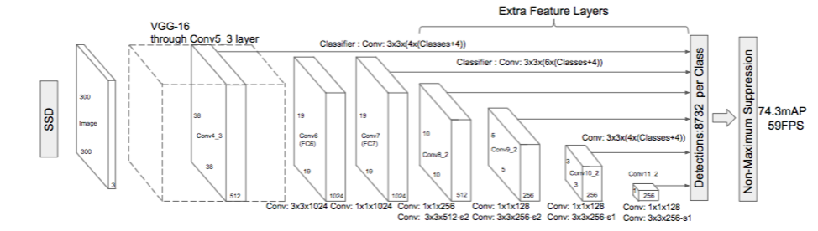

Figure 225 SSD architecture

SSD uses VGG16 (a variant of VGGNet that is previously explained in Section 2.4.4) to extract feature maps. The object is then detected using auxiliary convolutional layers.

Multibox is the process of making multiple predictions containing boundary boxes and confidence scores. For example, figure 2.26, an 8x8 convolutional layer is drawn. In each cell, it makes 4 objects predictions. Each prediction is made up of a boundary box and 21 scores for every class (one extra class for no object). The highest score is selected as the class for the bounded object. If predictions have no object, SSD will store it as a class “0” to specify it.

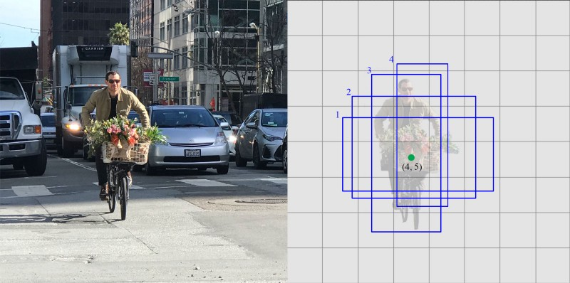

Figure 2.26 4 prediction at each cell.

### YOLO — You Only Look Once

YOLO or You Only Looks Once (Redmon, 2016) is an architecture that uses a single convolutional network to predicts the bounding boxes and class probabilities for these boxes. In YOLO, input image is taken and divided into SxS grid. Inside every grid, m bounding boxes are selected. For every bounding box, the network outputs a class probability and offset values. The bounding box that produces class probability over the threshold value is chosen and utilized to determine the object location across the image. YOLO, however, is having some challenges in locating small objects inside an image resulting from the algorithm spatial limitations.

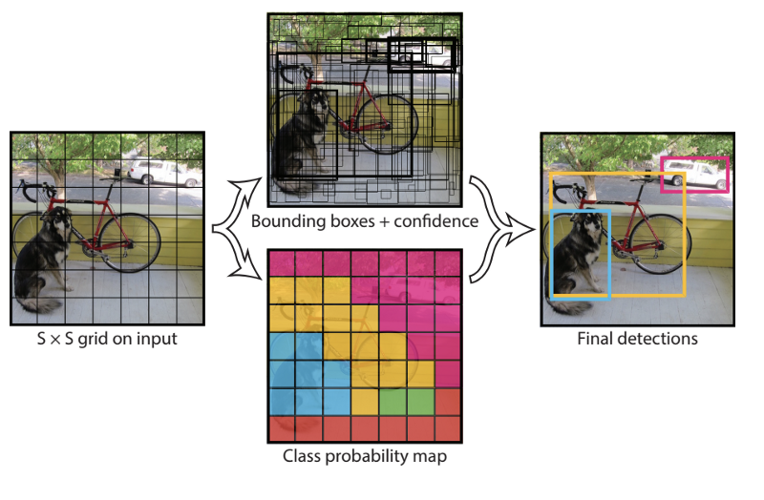

Figure 2.27 YOLO

## Transfer Learning

Since it is very uncommon to have datasets of adequate size, training of CNN is rarely done from scratch. Alternately, it is quite normal to pre-train CNN on a large dataset for example ImageNet. ImageNet holds around 1.2 million images with 1000 categories. Therefore, the usage of CNN can be as initialization or a fixed feature extractor for the task of interest (Vrochidis, Huet, Chang, & Kompatsiaris, 2019). Application of transfer learning can be as below scenarios:

* CNN as fixed feature extractor. The last FC layer is taken off from a pre-trained CNN and the rest of the CNN are treated as a fixed feature extractor in the new dataset.
* CNN fine-tuning. In this scenario, the approach is not only substituting and retraining the classifier on top of the CNN on a new dataset but to also tweak the weights of the pretrained network by carrying on the backpropagation.
* Pretrained models. Using the released final checkpoint from trained CNN that can apply for network fine-tuning.

## GPU usage in Object Detection algorithm

The usage of GPU has helped to speed up neural network and improve drastically the inference time of the algorithm. GPU is suitable for parallel programming due to its astounding number of cores. By using GPU, the detection speed for Faster R-CNN can be improved by 30% and the processing time in the proposal layer can be 2.5 times faster (Fukagai, et al., 2018). One of the advantages of using GPU, it can process a larger batch. Fukagai (2018) in their work also found out that by using a batch size of 16 on GPU, it can help to speed up Faster R-CNN 1.6 times faster than the original algorithm. This method is also applicable to other algorithms such as YOLO and SSD.

One of the deep learning frameworks that can support distributed implementation on CPU and GPU is TensorFlow (developed by Google). TensorFlow is a library (open-source) that maintains distributed implementation on GPU/CPU clusters and can automatically parallelize code for the ease of multi-threading (Sundar, Bonta, B, Baruah, & Sankara, 2018). In order to run TensorFlow with GPU on a system, the system needs to have GPU and CUDA (Compute Unified Device Architecture) installed. CUDA is a programming API and an architecture for parallel programming on GPU developed by NVIDIA in 2006 (Sunitha, Raju, & Chiplunkar, 2017). Once the correct CUDA drivers and necessary programming module have been installed, it is able to operate on single/multiple GPUs.

## Existing work

In this paper, existing work on CNN algorithms was studied. These algorithms are categories into two categories which is image classification and object detection.

### Image classification

Image classification is the method of analysing or classifying pixels in an image into classes or clusters (Das, 2018) where;

|  |  |
| --- | --- |
| Input: | Image data. |
| Output: | A class label of the image which the image belongs |

Table 2.1 summarize the existing work that have been studied for image classification.

Table 2.1 Existing work on image classification

|  |  |  |  |
| --- | --- | --- | --- |
| Author | Model | Strength\Limitation | Result |
| (Y. LeCun, 1998) | LeNet-5 | Introduce CNN with 7 layers for character recognition (handwritten and machine-printed character). This network is trained using the MNIST database. | Classifier error rate of 0.9% |
| (Krizhevsky, 2012) | AlexNet | Introduce deeper and larger CNN compared to CNN with 8 layers. The last 3 layers are fc layers. ReLu used as activation function. This algorithm has been trained using ImageNet Large-Scale Visual Recognition Challenge dataset (ILSVRC) 2010. dataset | Classifier error rate of 16.42% |
| (Zeiler & Fergus, 2014) | ZF Net | Enhancement to AlexNet by fine-tuning the hyperparameter. Some of the fine-tuning done were to expand the middle convolutional layers and having the stride and filter size smaller on the initial layer. This algorithm has been trained on ILSVRC 2013 dataset. | Classifier error rate of 11.2% |
| (Szegedy, Toshev, & Erhan, 2013) | GoogLeNet (Inception v1) | Introduces Inception module which reduce the number of parameters in the CNN network. This architecture also uses Average pooling rather Max pooling thus further reducing number of parameters. This algorithm has been trained on ILSVRC 2014 dataset. | Classifier error rate of 6.67% |
| (Szegedy, Vanhoucke, Ioffe, Shlens, & Wojna, 2016) | Inception v2 and  Inception v3 | Increased the accuracy and reduced the computational complexity by factorizing 5x5 convolution to two 3x3 convolution operations to improve computational speed. By stacking two 3x3 convolutions leads to a boost in performance. This architecture has been trained on ILSVRC 2012 dataset | Classifier error rate of 4.8% (Inception v2)  Classifier error rate of 3.58% (Inception v3) |
| (Simonyan & Zisserman, 2015) | VGGNet | Use only 3x3 convolution and 2x2 pooling throughout the network thus giving deeper depth and result. It proves depth of the network plays an important role. This algorithm has been trained on ILSVRC 2014 training set. | Classifier error rate of 7.32% |
| (He, Zhang, Ren, & Sun, 2016) | ReSNet | Introduce Residual block which solved the degradation problems which occurs as the network depth increases (accuracy get saturate and degrades rapidly). This algorithm has been trained on ILSVRC 2015 training set. | Classifier error rate of 3.5% |

### Object detection

Object detection is the process in answering a question of whether an object exist in an image (Cyganek, 2013). Image data is taken as input then outputting a class label from a set of classes. A bounding box is then drawn around the object to indicates its location within the image (localization).

|  |  |
| --- | --- |
| Input: | Image data |
| Output: | A class label of the image which the image belongs and a bounding box |

Table 2.2 summarize the existing work that have been studied for object detection.

Table 2.2 Existing work on object detection

|  |  |  |  |
| --- | --- | --- | --- |
| Author | Model | Strength\Limitation | Result |
| (Girshick, Donahue, Darrell, & Malik, 2014) | R-CNN | Selective search to extract 2000 regions (region proposals) from image. Region proposal generated using selective search algorithm. This architecture cannot be used in real time and required huge amount of training time. Learning process did not happen using selective search causing bad candidate region proposals generation. This algorithm was trained on ILSVRC 2012 dataset. | Result when trained on PASCAL VOC 2012 dataset  mAP: 53.3%  Test time :49s |
| (Girshick, Fast R-CNN, 2015) | Fast R-CNN | Input image is feed into CNN to generate convolutional feature map rather than using region proposal. Region proposal identified from convolutional feature map. This process is done once per image making it faster than R-CNN | Result when trained on PASCAL VOC 2007 and 2012  mAP: 70.0%  Test time :2s |
| (Ren, 2015) | Faster R-CNN | Introduces separate network to predict the region proposals and eliminates the usage of selective search algorithm thus making faster than R-CNN and Fast R-CNN. | Result when trained on PASCAL VOC 2007 and 2012  mAP: 73.2%  Test time: 0.14s |
| (Liu, et al., 2016) | SSD | Eliminates the usage of region proposal thus speeding up the process. To prevent drop-in accuracy, SSD applies multi-scale feature and default boxes. Does not works very well detecting small object. | Result when trained on PASCAL VOC 2007 and 2012  mAP: 79.8%  Test time: 0.05s |
| (Redmon, 2016) | YOLO | The bounding boxes and its class probabilities are predicted using a single convolutional network. YOLO, however, locating small objects inside an image resulting from the algorithm spatial limitations. | Result when trained on PASCAL VOC 2007 and 2012  mAP: 63.4%  Test time: 0.02s |

# RESEARCH METHODOLOGY

## Introduction

In Chapter 2, all necessary references for the studies were discussed. These include journals, thesis, technical papers, case studies, books, and websites related to the research. In this chapter, however, the approach adopted to accomplish the objectives of the research will be discussed. To have an effective research process, a well-design research methodology is required. Proper planning in outlining the stages for information and data collection is necessary.

## Operation framework

The framework for the research will describe the sequence of work to accomplish the research. Every step of getting information and data analysis will be shown in the framework. The Operational framework for the research as figure 3.1.

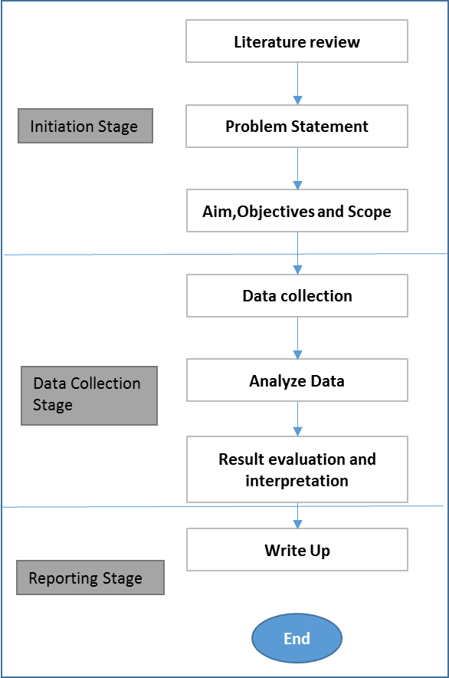

Figure 3.1 Flowchart of Research Methodology

### Initiation stage

The initiation stage for this research starts with defining the problem statement, the research aim, objective and scope. This is followed by a thorough literature review on CNN architectures, CNN common architecture, Object detection framework transfer learning and summary of the literature review. The initiation stage is summarized in table 3.1.

Table 3.1 Summary of initiation stage

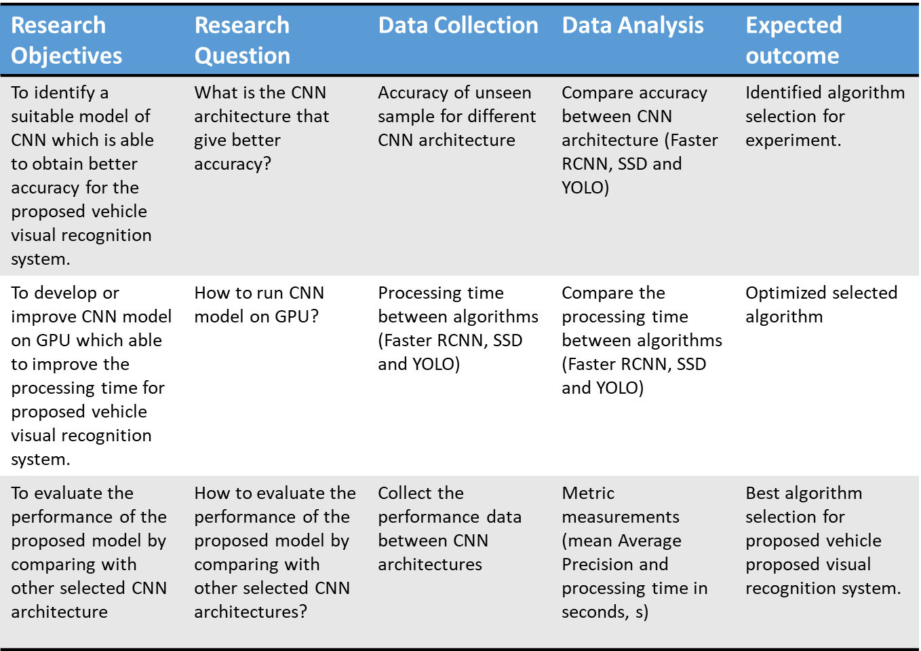

### Data collection stage

In this stage, the focus is on the data collection, selection of CNN object detection and algorithm that we want to use in our research, the feature of the data that going to be used in the experiment, and what also the evaluation method to use for the result.

#### Data sampling

The sample used for algorithm training are images of class 1,2,3,4,5 types of vehicles collected from the Internet. Total sample size of 448 images. The images are split into two folders. 90 images in the test folder and the rest of the images in the training folder. Two unseen samples (images that are not used in training and testing process) from car, taxi, lorry and bus from an actual expressway surveillance camera which monitor vehicles movement at the toll booth will be used to measure the algorithm performance in term of mean Average Precision (mAP) and inference time.

To search the images of the vehicles from the internet, specific keywords were used as below:

* Car
* Lorry
* Taxi
* Bus
* Taxi Malaysia
* Lorry Malaysia
* Bus Malaysia
* Highway CCTV

All images have been labeled using labelImg software and details of the object location within the images are stored into XML format file.

#### Algorithm Selection

From table 2.1 and table 2.2, below three object detection algorithms were selected due to the high accuracy of detection and fast test time taken to infer results.

1. Faster R-CNN
2. SDD
3. YOLO

For the backbone of the Faster R-CNN and SDD, Inception v2 was selected due to the low error rate and its network size that was reduced through the usage of the inception module. This will help to speed up the training and inception time. Inception v3 was not selected due to no pre-trained model available at the time of the research. For YOLO, YOLOv3 was selected as the YOLO architecture that will be use in the research experiment (aspects of the architecture will be explained in Section 4.3).

#### Images Selection

Selected images contain images of bus, lorry, taxi, and car. Effort has been made to select images with localized features. Refer to figure 1.5 in Chapter 1 for localized vehicle features examples. These examples include:

* Budget taxi (primarily painted in red or red and white color using older Proton car model such as Saga, Iswara, Wira or Waja)
* Premier taxis (primarily uses Proton Exora model and painted in light brown color).
* Executive taxis (uses larger car model and painted in cherry blue color)

#### Metric selection

This project will focus on the accuracy of the classifier and time taken for inception since it will be used to monitor traffic movement on the expressway. For this project the metric that will be used are

1. mAP (mean Average Precision): metric to measure the accuracy of object detectors. The calculation of mAP is explained as below.

|  |  |
| --- | --- |
| $$Precision=\frac{TP}{TP+FP}$$ | (3.1) |
| $$Recall=\frac{TP}{TP+FN}$$ | (3.2) |

Where;

|  |  |
| --- | --- |
| Precision: | Measures accuracy of the predictions. |
| Recall: | Measures how good the algorithm find all the positives. |
| *TP*: | True positive |
| *TN*: | True negative |
| *FP*: | False positive |
| *FN*: | False negative |

AP is calculated by finding the area under the precision-recall curve.

|  |  |
| --- | --- |
| $$AP=\int_{0}^{1}{p\left(r\right)dr}$$ | (3.3) |

mAP is the average of AP.

1. Inception time: time taken for inception

### Reporting stage

In the reporting stage, write up on the findings and summary of the studies will be done. This will include the conclusion, limitation and future work for this research.

## Study phases

There are two study phases in the research.

Phase 1: Object detection algorithm is run on the Faster R-CNN image samples and initial result data is collected. To validate the result, samples have been divided into training samples (358 samples) and test samples (90samples).

Phase 2: In the second phase, the best object detection algorithm based on the experiment result is selected for the proposed application. The application is then run using the real environment (expressway CCTV) testing data set.

## Tools and Platforms

In this research, the computation tool specification that will be used is as below.



This research will be using Google Colab as the training and inference platform. TensorFlow is used as the machine learning framework in which the library for running the algorithm with GPU is located as explained in Section 2.7. In this research, Python programming language will be used to create the algorithm training and inference program. For the experiment, it will run on Tesla K80 with below TensorFlow and CUDA version.

|  |  |
| --- | --- |
| TensorFlow version: | 1.13.1 |
| CUDA version: | V10.0.130 |
| Python version: | 3.6.7 |

## Summary

This chapter highlights the methodology used for this research. Research objectives and questions are addressed accordingly.

# FINDING

In this chapter, the initial finding of the research will be discussed. This will include the proposed system, experiment environment setup and data pre-processing.

## Proposed system

To meet the system requirement, this research is proposing the usage of Convolutional Neural Network (CNN) as the visual recognition engine. This research will also do some performance comparison between several CNN architectures in terms of vehicle classification accuracy and the speed of inference process. Research is also being done to select techniques to speed up the training and reduce the required training sample for CNN training. By doing so this research hopes to come out with the best algorithm for the proposed fraudulent cross-checking system.

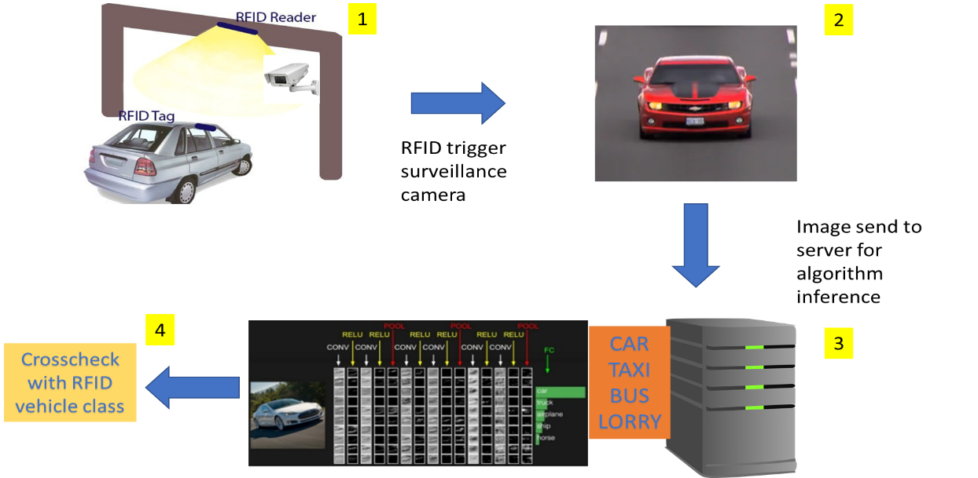

Figure 4.1 Proposed fraudulent cross-checking system

## Data pre-processing

For data pre-processing, 448 samples images have been collected then split into test and train inside models\research\object_detection\images directory. The images are split as in table 4.1.

Table 4.1 Images split details

|  |  |  |
| --- | --- | --- |
| Vehicle type | Test folder images number | Train folder images number |
| Bus | 20 | 80 |
| Car | 20 | 82 |
| Taxi | 20 | 80 |
| Lorry | 20 | 80 |
| Expressway CCTV images | 10 | 36 |

The images are annotated using labelImg program as below example. (Refer to figure 4.2).

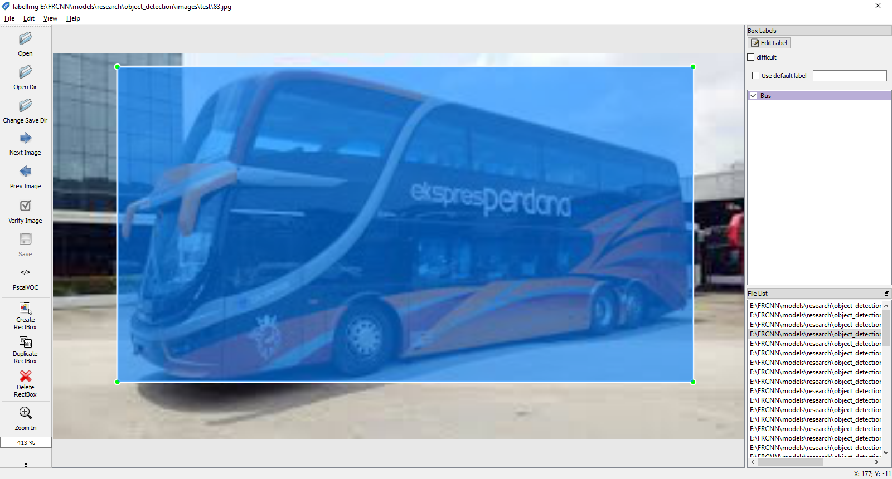

Figure 4.2 Image is annotate using labelImg

When image is saved, the program will create an XML file. The structure of the file is shown as below (refer to figure 4.3).

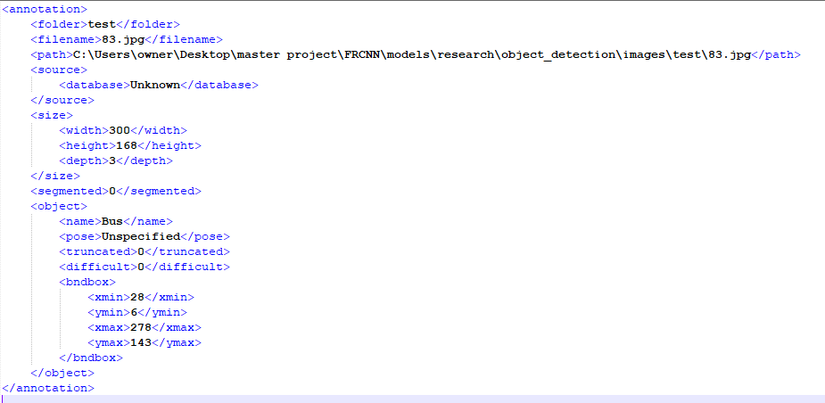

Figure 4.3 Example of the XML file structure

The XML file is then compiled for both test and train folder using below command which is run from the “object_detection” directory.

python XML_to_csv.py

The images XML files will be compiled into two CSV files which are test_labels.csv and train_labels.csv.

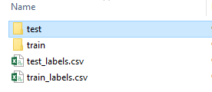

Figure 4.4 images folder structure

## Classification network

The classification network is the architecture of neural network that is being adopted to classify object in the object detection algorithm. In the research experiment, below classification network algorithm will be applied as the backbone for Faster R-CNN, SSD, and YOLO.

### Faster R-CNN and SSD

For Faster R-CNN and SSD object detection algorithm, Inception v2 architecture is used as the backbone of the algorithm. This network combines a few different inception modules in its architecture. The inception modules are displayed in figure 4.5, figure 4.6, and figure 4.7.

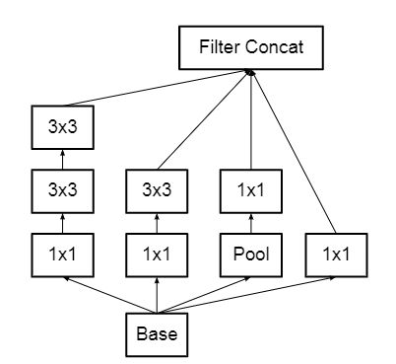

Figure 4.5 Inception modules where each 5×5 convolution is re-placed by two 3×3 convolution

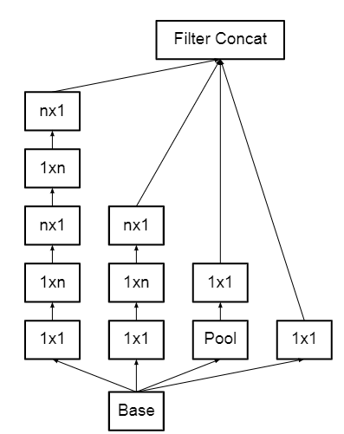

Figure 4.6 Inception modules after the factorization of the n×n convolutions. In this architecture n=7 for 17x17 was selected.

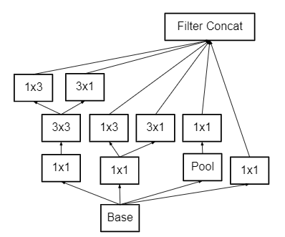

Figure 4.7 Inception modules with expanded the filter bank outputs. This architecture is used on the coarsest (8×8) grids to promote high dimensional representations.

The outline architecture of the model that will be used in the experiment is as table 4.2.

Table 4.2 Inception v2 architecture outline

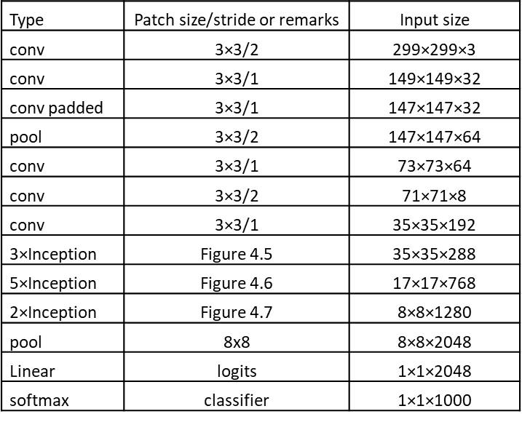

From onwards, Faster R-CNN and SSD will respectively rename to Faster R-CNN-Inception v2 and SSD-Inception v2 to reflect the backbone of the object detection algorithms.

### YOLO

In the experiment, YOLOv3 (Redmon J. a., 2018) architecture will be used as the feature extractor. This architecture uses 53 convolutional layers thus providing much deeper layers for the network. (Refer to figure 4.8).

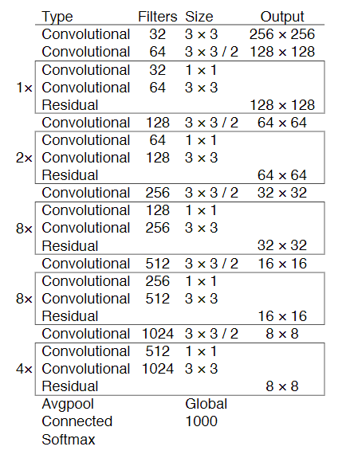

Figure 4.8 YOLOv3 architecture

From onwards, the research will use YOLOv3 instead of YOLO to reflect the architecture used in the experiment.

## Training process evaluation

The loss function is used to evaluate the algorithm training process Loss is calculated on the training and validation on how well the model is doing for these two sets of data. It is also represented as the summation of error made for each sample in the training or validation data sets. In neural network, it typically seeks to minimize the error. Faster R-CNN-Inception v2 loss function

For Faster R-CNN-Inception v2, the loss is calculated from the Region Proposal Network. The calculation of loss function for Faster R-CNN-Inception v2 is as below.

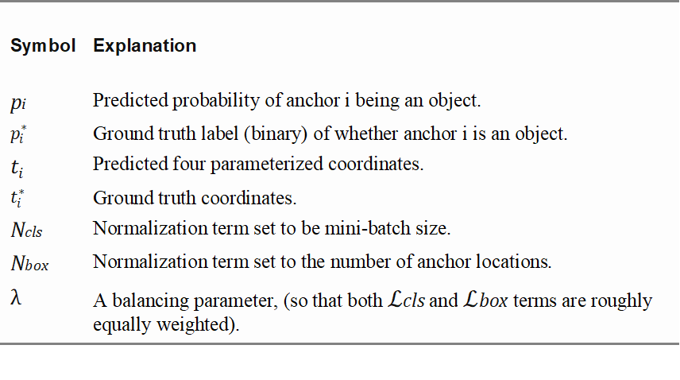

The multi-task loss function merges the losses from classification and bounding box regression:

|  |  |
| --- | --- |
| $L$*= $L$ cls+ $L$ box* | (4.1) |
| $L$*({pi},{ti})=cls(pi,* pi\**)+*∑i *(−* *)* | (4.2) |

where Lcls is the log loss function across two classes, as it can easily interpret a multi-class classification into a binary classification by predicting a sample being the target object or not. L 1smooth is the smooth L1 loss.

|  |  |
| --- | --- |
| $L$*cls* (pi, pi*)=− pi*log pi,−(1− pi*)log(1− pi) | (4.3) |

Figure 4.9 shows the classification loss from Faster R-CNN-Inception v2 algorithm training for the experiment training dataset. From the observation made, the graph is showing decreasing loss pattern as the training progress. The loss starts to stabilize at ~ 20 000 steps.

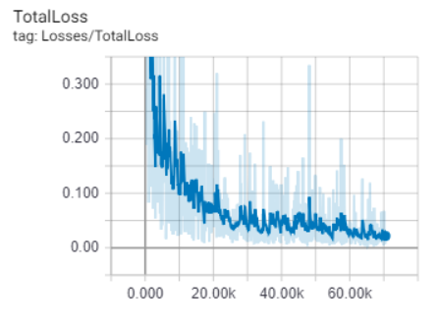

Figure 4.9 Faster R-CNN-Inception v2 loss for experiment training dataset

### SSD-Inception v2 loss function

The loss function for SSD-Inception v2 is the sum of localization loss and classification loss. The calculation for the loss function can be explain as below equation.

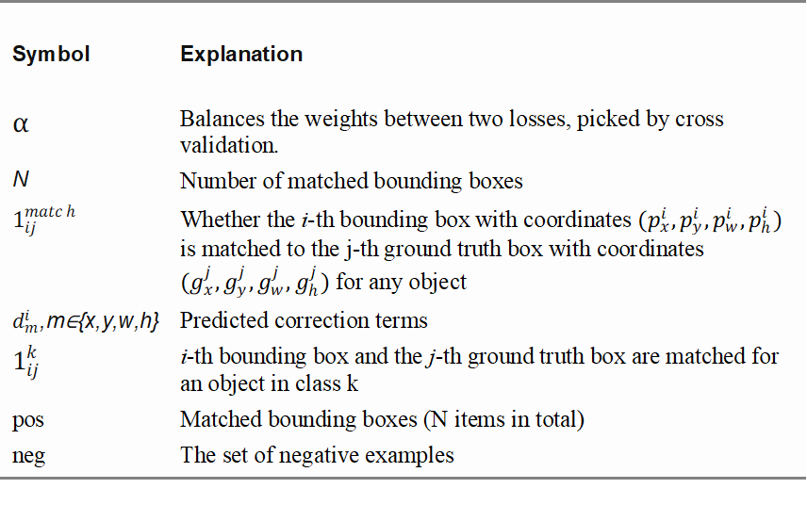Loss function is calculated as,

|  |  |
| --- | --- |
| $L$ = $\frac{1}{N}$ ($L$ cls+α $L$ loc) | (4.4) |

where localization loss is calculated as smooth L1 loss between the predicted bounding box correction and true values.

|  |  |
| --- | --- |
| $L$ loc= $\sum_{ij}{\sum_{m∈\left\{x,y,w,h\right\}}{1_{ij}^{match}}}L_{1}^{smooth}{(d_{m}^{i}-t_{m}^{j})}^{2}$ | (4.5) |
|  | (4.6) |
| $$t_{x }^{j}=(g_{x}^{j}-p_{x}^{i})/p_{w}^{i}$$ | (4.7) |
| $$t_{y }^{j}=(g_{y}^{j}-p_{y}^{i})/p_{h}^{i}$$ | (4.8) |
| $$t_{w }^{j}=log⁡(g_{w}^{j}/p_{w}^{i})$$ | (4.9) |
| $$t_{h}^{j}=log⁡(g_{h}^{j}/p_{h}^{i})$$ | (4.10) |

Classification loss calculated as softmax loss over multiple classes.

|  |  |
| --- | --- |
| $$L_{cls}=-\sum_{i∈pos}{1_{ij}^{k}}\log\left({\hat{c}}_{j}^{k}\right)-\sum_{i∈neg}{\log\left({\hat{c}}_{i}^{0}\right)},where {\hat{c}}_{i}^{k}=softmax(c_{i}^{k})$$ | (4.11) |

Below figure 4.10 shows the classification loss from SSD-Inception v2 algorithm training. From the observation made, the graph is showing decreasing loss as the training progress and starts stabilizing at ~2000 steps.

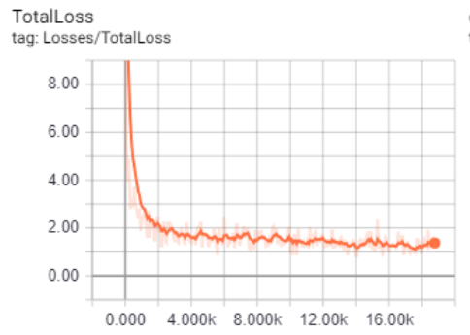

Figure 4.10 SSD-Inception v2 loss for experiment training dataset

### YOLOv3 loss function

YOLOv3 loss function can be calculated by summing the bounding box offset prediction location loss and conditional class probabilities classification loss.

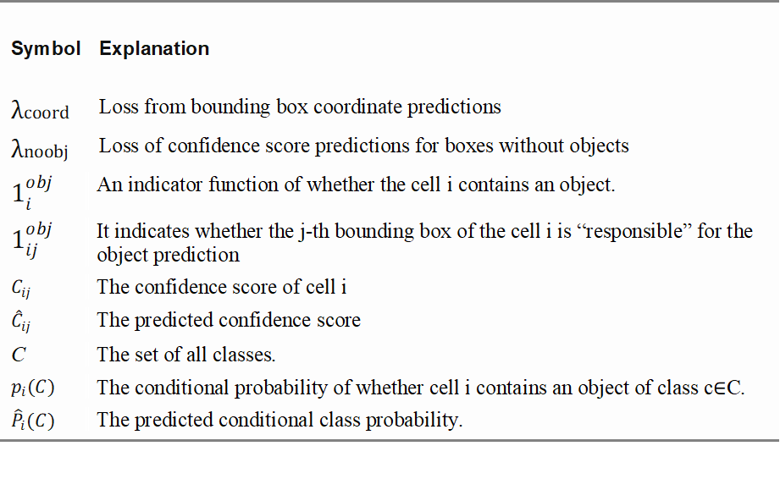

|  |  |
| --- | --- |
| $$L_{loc}=λcoord\sum_{i=0}^{s^{2}}{\sum_{j=0}^{B}{1_{ij}^{obj}}}\left[{\left(x_{i}-{\hat{x}}_{i}\right)}^{2}+ {\left(y_{i}-{\hat{y}}_{i}\right)}^{2}+{\left(\sqrt{w_{i}}- \sqrt{{\hat{w}}_{i}}\right)}^{2}+ {\left(\sqrt{h_{i}}- \sqrt{h_{i}}\right)}^{2}\right]$$ | (4.12) |
| $$L_{cls}=\sum_{i=0}^{s^{2}}{\sum_{j=0}^{B}{\left(1_{ij}^{obj}+λnoobj\left(1-1_{ij}^{obj}\right)\right){\left(C_{ij}-\hat{C_{ij}}\right)}^{2}+ \sum_{i=0}^{s^{2}}{\sum_{c∈C}{1_{i}^{obj }{\left(p_{i}\left(C\right)-{\hat{p}}_{i}\left(C\right)\right)}^{2}}}}}$$ | (4.13) |
| $$L=L_{loc}+L_{cls}$$ | (4.14) |

The classification error will only be penalized by the loss function if an object is detected within the grid cell, $1_{ij}^{obj}$ =1. It also only penalizes bounding box coordinate error if that predictor is “responsible” for the ground truth box, $1_{ij}^{obj}$ =1.

Below figure shows the loss from experiment YOLOv3 algorithm training. The loss for this algorithm training does not improve after 700 steps (~20).

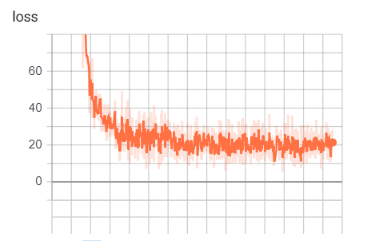

Figure 4.11 YOLOv3 loss for experiment training dataset

### Training process evaluation summary

From the training process evaluation, the lost function for each algorithm training can be summarized as below table.

Table 4.3 Algorithm loss summary

|  |  |
| --- | --- |
| Algorithm | Loss |
| Faster R-CNN-Inception v2 | ~0.03 |
| SSD-Inception v2 | ~1.3 |
| YOLOv3 | ~20 |

From the training done, it can be concluded that the YOLOv3 algorithm used in the experiment dataset training has a high loss function. It is suspected that the sample size used in the training is not enough to train the algorithm. Due to the high loss factor, it was decided not to use YOLOv3 algorithm for further experiment.

## Experiment design

To conduct the experiment, 8 images from the actual highway’s toll surveillance camera were used as the test images. The images then fed into the trained Faster R-CNN-Inception v2 and SSD-Inception v2 algorithms where the mAP and the time to infer the images were recorded. The stability test is done by calculating the standard deviation of the data. To compare the performance between the two algorithms, paired sample t-test was performed on the inference mAP and inference time. By using TensorFlow library, Faster R-CNN-Inception v2 and SSD-Inception v2 algorithms used in the experiment were optimized to use GPU for image processing (refer to Section 2.7). Images used for the experiment are shown in table 4.4.

Table 4.4 Images used in experiments

|  |  |  |
| --- | --- | --- |
| Image | Image File Name | Image class |
|  | Taxi 1 | Taxi |
|  | Taxi 2 | Taxi |
|  | Lorry 1 | Lorry |
|  | Lorry 2 | Lorry |
|  | Bus 1 | Bus |
|  | Bus 2 | Bus |
|  | Car 1 | Car |
|  | Car 2 | Car |

## Experiment results

This section will summarize the experiment result for inference mAP, inference time and the stability of the algorithm.

### Inference mAP

The inference mAP results are displayed in table 4.5.

Table 4.5 mAP results

|  |  |  |  |
| --- | --- | --- | --- |
| Image name | Image class | Algorithm inference mAP [%] | |
| Faster R-CNN-Inception v2 | SSD-Inception v2 |
| Taxi 1 | Taxi | 97.67 | 97.44 |
| Taxi 2 | Taxi | 99.94 | 83.48 |
| Lorry 1 | Lorry | 99.38 | 99.58 |
| Lorry 2 | Lorry | 99.91 | 79.19 |
| Bus 1 | Bus | 66.40 | 99.01 |
| Bus 2 | Bus | 43.53 | 84.16 |
| Car 1 | Car | 99.90 | 99.82 |
| Car 2 | Car | 93.35 | 98.55 |

From the findings based on table 4.5 mAP results, it can observe that the performance of the algorithms will vary according to the images. SSD-Inception v2 produces better mAP for Lorry 1, Bus 1, Bus 2 and Car 1 while Faster R-CNN-Inception v2 produces better mAP for Taxi 1, Taxi 2, Lorry 2 and Car 1. Table 4.6 shows the images after inference with the bounding box and mAP.

Table 4.6 Object detection bounding box and mAP

|  |  |  |
| --- | --- | --- |
| Image name | Faster R-CNN-Inception v2 | SSD-Inception v2 |
| Taxi 1 |  |  |
| Taxi 2 |  |  |
| Lorry 1 |  |  |
| Lorry 2 |  |  |
| Bus 1 |  |  |
| Bus 2 |  |  |
| Car 1 |  |  |
| Car 2 |  |  |

### Inference time

The inference time results are displayed in table 4.7.

Table 4.7 Inference time, t results

|  |  |  |  |  |  |
| --- | --- | --- | --- | --- | --- |
| Image name | Image class | Algorithm inference time, t in [s] | | Differences in [s] | |
| Faster R-CNN-Inception v2 | SSD-Inception v2 |  |
| Taxi 1 | Taxi | 0.0638 | 0.0352 | 0.0286 |
| Taxi 2 | Taxi | 0.0977 | 0.0686 | 0.0291 |
| Lorry 1 | Lorry | 0.0609 | 0.0370 | 0.0239 |
| Lorry 2 | Lorry | 0.1032 | 0.0761 | 0.0271 |
| Bus 1 | Bus | 0.1159 | 0.0886 | 0.0273 |
| Bus 2 | Bus | 0.1100 | 0.0824 | 0.0276 |
| Car 1 | Car | 0.0613 | 0.0324 | 0.0289 |
| Car 2 | Car | 0.0598 | 0.0330 | 0.0268 |

From the findings based on table 4.7, the inference time will vary according to the complexity of the images. The inference time taken using SSD-Inception v2 algorithm is on average 0.027 seconds faster compared to Faster R-CNN-Inception v2.

### Stability test

For the stability test, each sample is feed through the algorithms 30 times and the standard deviation is calculated based on the results from table 4.8 and table 4.9.

1. Inference mAP

Table 4.8 shows the result of standard deviation for Faster R-CNN-Inception v2 and SSD-Inception v2 mAP.

Table 4.8 mAP standard deviation and mean

|  |  |  |  |
| --- | --- | --- | --- |
| Items | | Standard deviation | Mean |
| Taxi 1 | Faster R-CNN-Inception v2 | 3.39E-16 | 97.67% |
| SSD-Inception v2 | 0.00E+00 | 97.44% |
| Taxi 2 | Faster R-CNN-Inception v2 | 2.26E-16 | 99.94% |
| SSD-Inception v2 | 3.39E-16 | 83.48% |
| Bus 1 | Faster R-CNN-Inception v2 | 1.13E-16 | 66.40% |
| SSD-Inception v2 | 6.78E-16 | 99.01% |
| Bus 2 | Faster R-CNN-Inception v2 | 2.82E-16 | 43.53% |
| SSD-Inception v2 | 1.13E-16 | 84.16% |
| Lorry 1 | Faster R-CNN-Inception v2 | 5.65E-16 | 99.38% |
| SSD-Inception v2 | 3.39E-16 | 99.58% |
| Lorry 2 | Faster R-CNN-Inception v2 | 3.39E-16 | 99.91% |
| SSD-Inception v2 | 0.00E+00 | 79.19% |
| Car 1 | Faster R-CNN-Inception v2 | 0.00E+00 | 99.90% |
| SSD-Inception v2 | 3.39E-16 | 99.82% |
| Car 2 | Faster R-CNN-Inception v2 | 6.78E-16 | 93.35% |
| SSD-Inception v2 | 6.78E-16 | 98.55% |

From table 4.8, the calculated standard deviation for both Faster R-CNN-Inception v2 and SSD-Inception v2 are in the range of 0 to 6.78E-16. The standard deviation is very small for both Faster R-CNN-Inception v2 and SSD-Inception v2 mAP results, so it can be concluded that the mAP result for both algorithms is very stable in terms of mAP result.

1. Inference time, t

Table 4.8 shows the result of standard deviation for Faster R-CNN-Inception v2 and SSD-Inception v2 inference time.

Table 4.9 Inference time, t standard deviation and mean

|  |  |  |  |
| --- | --- | --- | --- |
| Items | | Standard deviation | Mean |
| Taxi 1 | Faster R-CNN-Inception v2 | 2.30E-03 | 0.0638 |
| SSD-Inception v2 | 4.00E-03 | 0.0352 |
| Taxi 2 | Faster R-CNN-Inception v2 | 5.06E-03 | 0.0977 |
| SSD-Inception v2 | 6.33E-03 | 0.0686 |
| Bus 1 | Faster R-CNN-Inception v2 | 5.64E-03 | 0.1159 |
| SSD-Inception v2 | 6.59E-03 | 0.0886 |
| Bus 2 | Faster R-CNN-Inception v2 | 5.07E-03 | 0.1100 |
| SSD-Inception v2 | 7.81E-03 | 0.0824 |
| Lorry 1 | Faster R-CNN-Inception v2 | 2.79E-03 | 0.0609 |
| SSD-Inception v2 | 4.47E-03 | 0.0370 |
| Lorry 2 | Faster R-CNN-Inception v2 | 6.26E-03 | 0.1032 |
| SSD-Inception v2 | 5.79E-03 | 0.0761 |
| Car 1 | Faster R-CNN-Inception v2 | 2.32E-03 | 0.0613 |
| SSD-Inception v2 | 4.31E-03 | 0.0324 |
| Car 2 | Faster R-CNN-Inception v2 | 2.54E-03 | 0.0598 |
| SSD-Inception v2 | 3.94E-03 | 0.0330 |

From table 4.9, the standard deviation range for both Faster R-CNN-Inception v2 and SSD-inception v2 in the range of 2.30E-03 and 7.81E-03. This shows that the standard deviation for inference time for both Faster R-CNN-Inception v2 and SSD-Inception v2 is very small and can be concluded that the algorithms are very stable in terms of inference time.

### Paired sample t- test

The paired sample t-test was used to determine whether the experimental results can be proven statically or not. In this section, the scope of the paired sample t-test covers the test data for both Faster R-CNN-Inception v2 and SSD-Inception v2 mAP and inference time. Based on the literature review done and the experiment test data, it is assumed that the performance of SSD-Inception v2 is better than Faster R-CNN-Inception v2 and inference time result thus below hypothesis has been proposed and tested.

1. Inference mAP

Null hypothesis,

$$H_{0}:μ_{SSD_mAP}-μ_{F-RCNN_mAP}=0$$

and the alternative hypothesis,

$$H_{a}:μ_{SSD_mAP}-μ_{F-RCNN_mAP}>0$$

Paired t-sample test result for mAP

Table 4.10 mAP Paired 2 sample t-test

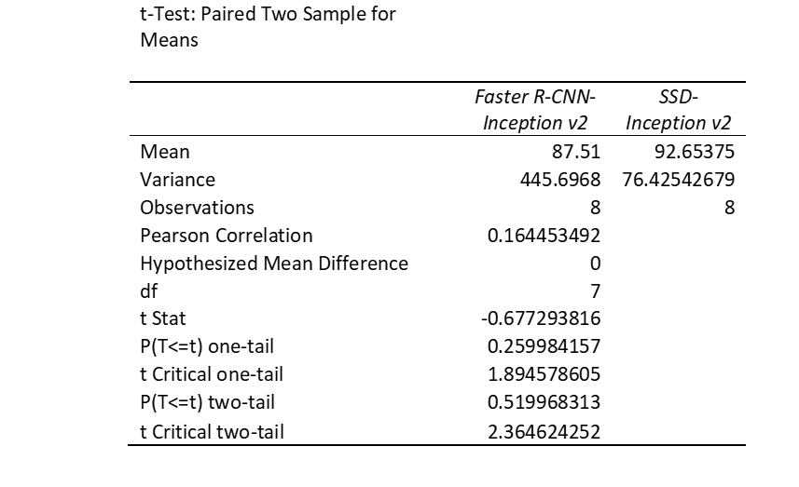

From the paired t-sample test result above, it can be observed that the t Stat value is 0.67 is less than the t critical one-tail value of 1.89, so the alternative hypothesis is rejected, and the null hypothesis is accepted. This result proves that statically there is no notable difference between Faster R-CNN-Inception v2 mAP and SSD-Inception v2 mAP..

1. Inference time t,

Null hypothesis,

$$H_{0}:μ_{SSD_t}-μ_{F-RCNN_t}=0$$

and the alternative hypothesis,

$$H_{a}:μ_{SSD_t}-μ_{F-RCNN_t}>0$$

Paired t-sample test result for inference time

Table 4.11 Inference time, t Paired 2 sample t-test

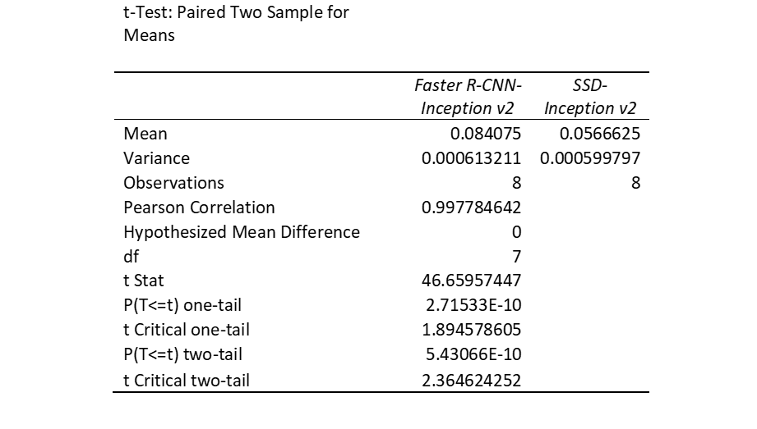

From the paired t-sample test result above, it can be observed that the t Stat value is 46.66 is bigger than the t critical one-tail value of 1.89, so the alternative hypothesis is accepted, and the null hypothesis is rejected. This result confirms that statically there is a notable difference between Faster R-CNN-Inception v2 inference time and SSD-Inception v2 inference time.

## Summary

From the algorithms training and experiments result that we conducted in this research, we can summarize it as in below table.

Table 4.12 Finding summary

|  |  |  |  |
| --- | --- | --- | --- |
| Items | Faster R-CNN-Inception v2 | SSD-Inception v2 | YOLOv3 |
| Training Loss | ~0.03 | ~1.3 | ~20 |
| Inference mAP | It can observe that the performance of the algorithms will varies according to the images. SSD-Inception v2 produces better mAP for Lorry1, Bus 1, Bus 2 and Car 1 while Faster R-CNN-Inception v2 produces better mAP for Taxi 1, Taxi 2, Lorry 2 and Car 1. | | - |
| Inference time, t | SSD-Inception v2 inference time is on average 0.027 seconds faster compared to Faster R-CNN-Inception v2. | | - |
| Stability test | Both algorithms are very stable in terms of mAP and inference times | | - |
| Paired sample t-test | Statically, there is no difference in performance between Faster R-CNN-Inception v2 and SSD-Inception v2 for mAP but there is a significant difference in inference time performance. This supports result from table 4.7, | | - |

# CONCLUSION

Chapter 4 explained on the proposed system, experiment environment setup, data pre-processing, training loss, experiment design, and our experiment results. This chapter will discuss the conclusion of the research which will include the research outcomes, contribution to knowledge, limitation, and future works.

## Research Outcomes

During the algorithm training process, it is found that YOLOv3 losses are quite high (~20) thus producing poor initial mAP results when tested against experiment test samples. Therefore, it was decided to drop YOLOv3 from the research experiment. The training and inference experiment for Faster R-CNN-Inception v2 and SSD-Inception v2 was done using google Colab.

From the experiment, it can be concluded, both Faster R-CNN-Inception v2 and SSD-Inception v2 produce a stable result for the inference mAP and time. It also found that the mAP results and inference time between Faster R-CNN-Inception v2 and SSD-Inception v2 will vary according to the complexity of samples tested. Paired sample t-test was conducted to validate experiment results statically, to show if there are really any differences in mAP and inference time performance between Faster R-CNN-Inception v2 and SSD-Inception v2. From the paired sample t-test result, it can be concluded that there are no notable differences in inference mAP for both Faster R-CNN-Inception v2 and SSD-Inception v2. However, there was a notable difference in inference time which SSD-Inception v2 is on average 0.027 seconds faster compared to Faster R-CNN-Inception v2. This was supported by the paired sample t-test conducted on the average inference time between both algorithms.

Considering the literature review and experiments result, it concluded that SSD-Inception v2 is the best algorithm to be used for the vehicle recognition system. Although the SSD-Inception v2 mAP performance is on par with Faster R-CNN-Inception v2, it is significantly having faster inference time. The research objectives have been achieved by the following items.

Objective 1 has been achieved by doing details research on literature reviews as explained in Chapter 2. From the literature review, the research identifies Faster R-CNN-Inception v2, SSD-Inception v2, and YOLOv3 as the algorithms going to be used in the research experiment.

Objective 2 has been achieved by developing the algorithms model in TensorFlow machine learning framework. As explained in Section 2.7, TensorFlow has a built-in library that allows automatic parallelize code for the ease of multi-threading using GPU.

Objective 3 has been accomplished by evaluating and comparing the performance of Faster R-CNN-Inception v2, SSD-Inception v2, and YOLOv3. However, during the training process, YOLOv3 produced a high loss function. The research experiment was conducted using only Faster R-CNN-Inception v2 and SSD-Inception v2 due to the high loss function in YOLOv3.

## Contributions to Knowledge

This research contributed to the knowledge by providing a comparison between Faster R-CNN-Inception v2 and SSD-Inception v2 performance in terms of mAP and inference time in which SSD-Inception v2 performs better compared to Faster R-CNN-Inception v2. It is also noted that both algorithms are very stable.

## Limitation

There was a limitation on sample size, type of images and image orientation used in the experiments. The current sample size of 448 samples are considered as small and this may have influenced the algorithms training process. Images for class 2 and class 3 vehicle which are currently grouped and labelled as Lorry, will prevent these classes to be identified separately. The object orientation of the images, for example, views from the front, back, side and up can also influence the algorithms training and inference results.

There was also some knowledge limitation on how to train YOLOv3 algorithms. YOLOv3 was initially trained on Darknet framework, however, in this experiment, the training was done using Darkflow which is a library converted from Darknet to accommodate YOLOv3 training and execution on TensorFlow. More studies are needed to perform YOLOv3 training on TensorFlow.

## Future Works

In the experiment, class 2 and class 3 vehicles were grouped as Lorry, thus object detection and classification were performed only for Lorry type. For future work, class 2 and class 3 samples should separately be labelled and train to reflect the real-life application of the algorithm. In the experiment, YOLOv3 was excluded due to high function loss. More studies needed to improve the loss function, so it can be included in future works.

# REFERENCES

Abadi, M., Barham, P., Chen, J., Chen, Z., Davis, A., Dean, J., . . . Zheng, X. (2016). TensorFlow: a system for large-scale machine learning. *arXiv: Distributed, Parallel, and Cluster Computing*, 265-283. Retrieved 11 19, 2018, from https://arxiv.org/abs/1605.08695

Albawi, S., Mohammed, T. A., & Al-Zawi, S. (2017). Understanding of a convolutional neural network. *International Conference on Engineering and Technology (ICET).* Antalya, Turkey: IEEE. Retrieved from CS231: http://cs231n.stanford.edu/

Boyer, V., & Baz, D. E. (2013). Recent Advances on GPU Computing in Operations Research. *2013 IEEE International Symposium on Parallel & Distributed Processing, Workshops and Phd Forum* (pp. 1778-1787). Cambridge, MA: IEEE. Retrieved 11 16, 2018, from http://projects.laas.fr/nvidiaacademic/4979b778.pdf

Chen, T., Li, M., Li, Y., Lin, M., Wang, N., Wang, M., . . . Zhang, Z. (2015). MXNet: A Flexible and Efficient Machine Learning Library for Heterogeneous Distributed Systems. *arXiv: Distributed, Parallel, and Cluster Computing*. Retrieved 11 19, 2018, from https://arxiv.org/abs/1512.01274

Cyganek, B. (2013). *Object Detection and Recognition in Digital Images: Theory and Practice.* John Wiley & Sons.

Das, R. D. (2018). *Feature Dimension Reduction for Content-Based Image Identification.* IGI Global.

Deng, J., Dong, W., Socher, R., Li, L.-J., Li, K., & Fei-Fei, L. (2009). ImageNet: A large-scale hierarchical image database. *2009 IEEE Conference on Computer Vision and Pattern Recognition*, (pp. 248-255). Miami, FL. Retrieved 10 28, 2018, from http://image-net.org/papers/imagenet_cvpr09.pdf

Fukagai, T., Maeda, K., Tanabe, S., Shirahata, K., Tomita, Y., Ike, A., & Nakagawa, A. (2018). Speed-Up of Object Detection Neural Network with GPU. *IEEE International Conference on Image Processing (ICIP)* (pp. 301 - 305). Athens, Greece: IEEE.

Geiger, A., Lenz, P., & Urtasun, R. (2012). Are we ready for Autonomous Driving? The KITTI Vision Benchmark Suite. *Conference on Computer Vision and Pattern Recognition (CVPR).*

Girshick, R. B. (2015). Fast R-CNN. *arXiv: Computer Vision and Pattern Recognition*, 1440-1448. Retrieved 11 22, 2018, from https://arxiv.org/pdf/1504.08083

Girshick, R. B., Donahue, J., Darrell, T., & Malik, J. (2014). Rich Feature Hierarchies for Accurate Object Detection and Semantic Segmentation. *arXiv: Computer Vision and Pattern Recognition*, 580-587. Retrieved 11 22, 2018, from https://arxiv.org/abs/1311.2524

Guerrero-Gómez-Olmedo, R., Torre-Jiménez, B., López-Sastre, R., Bascón, S. M., & Oñoro-Rubio, D. (2015). Extremely Overlapping Vehicle Countin. *Iberian Conference on Pattern Recognition and Image Analysis (IbPRIA).*

He, K., Zhang, X., Ren, S., & Sun, J. (2016). Deep Residual Learning for Image Recognition. *arXiv: Computer Vision and Pattern Recognition*, 770-778. Retrieved 11 21, 2018, from https://arxiv.org/pdf/1512.03385.pdf

Hussain, M. a. (2018). A Study on CNN Transfer Learning for Image Classification. *18th Annual UK Workshop on Computational Intelligence · UKCI 2018*.

Hussain, M., Bird, J. J., & Faria, D. R. (2018). A Study on CNN Transfer Learning for Image Classification. *UKCI 2018: Advances in Computational Intelligence Systems*, 191-202. Retrieved 11 19, 2018, from https://link.springer.com/chapter/10.1007/978-3-319-97982-3_16

Jonathan Krause, M. S.-F. (2013). 3D Object Representations for Fine-Grained Categorization. *4th IEEE Workshop on 3D Representation and Recognition.* Sydney, Australia: IEEE .

Ketkar, N. (2017). Introduction to PyTorch. In N. Ketkar, *Deep Learning with Python* (pp. 195-208). Apress, Berkeley, CA. Retrieved 11 19, 2018, from https://link.springer.com/chapter/10.1007/978-1-4842-2766-4_12

Krizhevsky, A. a. (2012, 2012). ImageNet Classification with Deep Convolutional Neural Networks. *NIPS*, (pp. 84-90). Retrieved 11 14, 2018, from http://www.image-net.org/challenges/LSVRC/2012/supervision.pdf

LeCun, Y., Cortes, C., & J.C. Burges, C. (2010). *THE MNIST DATABASE of handwritten digits*. Retrieved from yann.lecun: http://yann.lecun.com/exdb/mnist/

Lin, T.-Y., Maire, M., Belongie, S. J., Hays, J., Perona, P., Ramanan, D., . . . Zitnick, C. L. (2014). Microsoft COCO: Common Objects in Context. *arXiv: Computer Vision and Pattern Recognition*, 740-755. Retrieved 10 28, 2018, from https://arxiv.org/abs/1405.0312

Liu, W., Anguelov, D., Erhan, D., Szegedy, C., Reed, S. E., Fu, C.-Y., & Berg, A. C. (2016). SSD: Single Shot MultiBox Detector. *arXiv: Computer Vision and Pattern Recognition*, 21-37. Retrieved 11 22, 2018, from https://arxiv.org/abs/1512.02325

M. Cordts, M. O., Ramos, S., Rehfeld, T., Enzweiler, M., Benenson, R., Franke, U., . . . B. Schiele. (2016). The Cityscapes Dataset for Semantic Urban Scene Understanding. *IEEE Conference on Computer Vision and Pattern Recognition (CVPR)* (pp. 3213 - 3223). Las Vegas, NV, USA: IEEE.

Mayank Singh Chauhan, Arshdeep Singh, Khemka, M., Prateek, A., & Sen, R. (2019). Embedded {CNN} based vehicle classification and counting in non-laned. *arXiv:Computer Vision and Pattern Recognition*.

Mondal, M., Mondal, P., Saha, N., & Chattopadhyay, P. (2017). Automatic number plate recognition using CNN based self synthesized feature learning. *IEEE Calcutta Conference (CALCON).* Kolkata, India: IEEE.

Moolayil, J. (2018). *Learn Keras for Deep Neural Networks: A Fast-Track Approach to Modern Deep Learning with Python.* Apress;. Retrieved 11 19, 2018

Nakagawa, T. F. (2018). Speed-Up of Object Detection Neural Network with GPU. *2018 25th IEEE International Conference on Image Processing (ICIP)*, 301-305.

Noriani, M., Suriani, M., Nurulhuda, F., Rasimah, C., & Norziha, M. (2016). RFID-Based Electronic Fare Toll Collection System for Multi-Lane Free Flow - A Case Study towards Malaysia Toll System Improvement. *Journal of Telecommunication, Electronic and Computer Engineering*.

Ooi, J., Tay, L. C., & Lai, W. K. (2019). Bottom-hat filtering for Defect Detection with CNN Classification on Car Wiper Arm. *IEEE 15th International Colloquium on Signal Processing & Its Applications (CSPA).* Penang, Malaysia: IEEE.

Redmon, J. a. (2018). YOLOv3: An Incremental Improvement. *CoRR*.

Redmon, J. D. (2016). You Only Look Once: Unified, Real-Time Object Detection. . *2016 IEEE Conference on Computer Vision and Pattern Recognition (CVPR)*, 779-788.

Ren, S. H. (2015). Faster R-CNN: Towards Real-Time Object Detection with Region Proposal Networks. *IEEE Transactions on Pattern Analysis and Machine Intelligence, 39*, 1137-1149.

Simonyan, K., & Zisserman, A. (2015). Very Deep Convolutional Networks for Large-Scale Image Recognition. *arXiv: Computer Vision and Pattern Recognition*. Retrieved 11 20, 2018, from https://arxiv.org/pdf/1409.1556.pdf

Sujit, S. J., Gabr, R. E., Coronado, I., Robinson, M., Datta, S., & Narayana, P. A. (2018). Automated Image Quality Evaluation of Structural Brain Magnetic Resonance Images using Deep Convolutional Neural Networks. *Cairo International Biomedical Engineering Conference (CIBEC).* Cairo, Egypt: IEEE.

Sundar, K. V., Bonta, L. R., B, A. K., Baruah, P. K., & Sankara, S. S. (2018). Evaluating Training Time of Inception-v3 and Resnet-50,101 Models using TensorFlow across CPU and GPU. *Second International Conference on Electronics, Communication and Aerospace Technology (ICECA)* (pp. 1964 - 1968). Coimbatore, India: IEEE.

Sunitha, N. V., Raju, K., & Chiplunkar, N. N. (2017). Performance improvement of CUDA applications by reducing CPU-GPU data transfer overhead. *International Conference on Inventive Communication and Computational Technologies (ICICCT).* Coimbatore, India: IEEE.

Szegedy, C., Liu, W., Jia, Y., Sermanet, P., Reed, S. E., Anguelov, D., . . . Rabinovich, A. (2015). Going deeper with convolutions. *arXiv: Computer Vision and Pattern Recognition*, 1-9. Retrieved 11 15, 2018, from https://arxiv.org/abs/1409.4842

Szegedy, C., Toshev, A., & Erhan, D. (2013). Deep Neural Networks for Object Detection. *NIPS.* Retrieved 10 8, 2018, from http://papers.nips.cc/paper/5207-deep-neural-networks-for-object-detection.pdf

Szegedy, C., Vanhoucke, V., Ioffe, S., Shlens, J., & Wojna, Z. (2016). Rethinking the Inception Architecture for Computer Vision. *arXiv: Computer Vision and Pattern Recognition*, 2818-2826. Retrieved 3 21, 2019, from https://arxiv.org/pdf/1512.00567.pdf

Tatsuya, H., Kazuyoshi, K., Keiji, T., Kyoko, O., Shinichi , M., & Masafumi, S. (2016). Application of Radio Frequency Identification Technology to Toll Collection System. *Mitsubishi Heavy Industries Technical Review Vol. 53 No. 3*.

*Toll collection and toll rates*. (2006, September 1). Retrieved from LCCT: http://www.lcct.com.my/others/highways-and-toll/toll-collection-and-toll-rates/

*Toll Fare*. (2018). Retrieved from DUKE: http://www.duke.com.my/page/143/Toll-Fare/

Tom Hope, Y. S. (2017). *Learning TensorFlow A Guide to Building Deep Learning Systems.* O'Reilly Media.

Vrochidis, S., Huet, B., Chang, E. Y., & Kompatsiaris, I. (2019, 11 24). Transfer Represenation Learning. In S. Vrochidis, B. Huet, E. Y. Chang, & I. Kompatsiaris, *Big Data Analytics for Large-Scale Multimedia Search* (p. 16). United Kingdom: John\Wiley& Sons, Limited. Retrieved from CS231n Convolutional Neural Networks for Visual Recognition: http://cs231n.github.io/transfer-learning/

Wang, S., Li, Z., Zhang, H., & Ji, Y. (2017). Classifying vehicles with convolutional neural network and feature encoding. *IEEE 14th International Conference on Industrial Informatics (INDIN).* Poitiers, France: IEEE.

Y. LeCun, L. B. (1998). Gradient-based learning applied to document recognition. *Proceedings of the IEEE, vol. 86, no. 11* (pp. 2278-2324). IEEE.

Zeiler, M. D., & Fergus, R. (2014). Visualizing and Understanding Convolutional Networks. *arXiv: Computer Vision and Pattern Recognition*, 818-833. Retrieved 11 15, 2018, from https://arxiv.org/pdf/1311.2901

Zhao, Z., Zheng, P., Xu, S., & Wu, X. (2019). Object Detection With Deep Learning: A Review. *IEEE Transactions on Neural Networks and Learning Systems*, 1-21.